# Useful links to both of current used Graylogs.
https://ha-graylog.tcsbank.ru/streams
https://ha-graylog.tcsbank.ru/system/authentication/users

https://graylog.tcsbank.ru/streams
https://graylog.tcsbank.ru/system/authentication/users

#
# Before cloning a Stream, need to know what contains follow fields. Then, reproduce it during clonning new Stream.
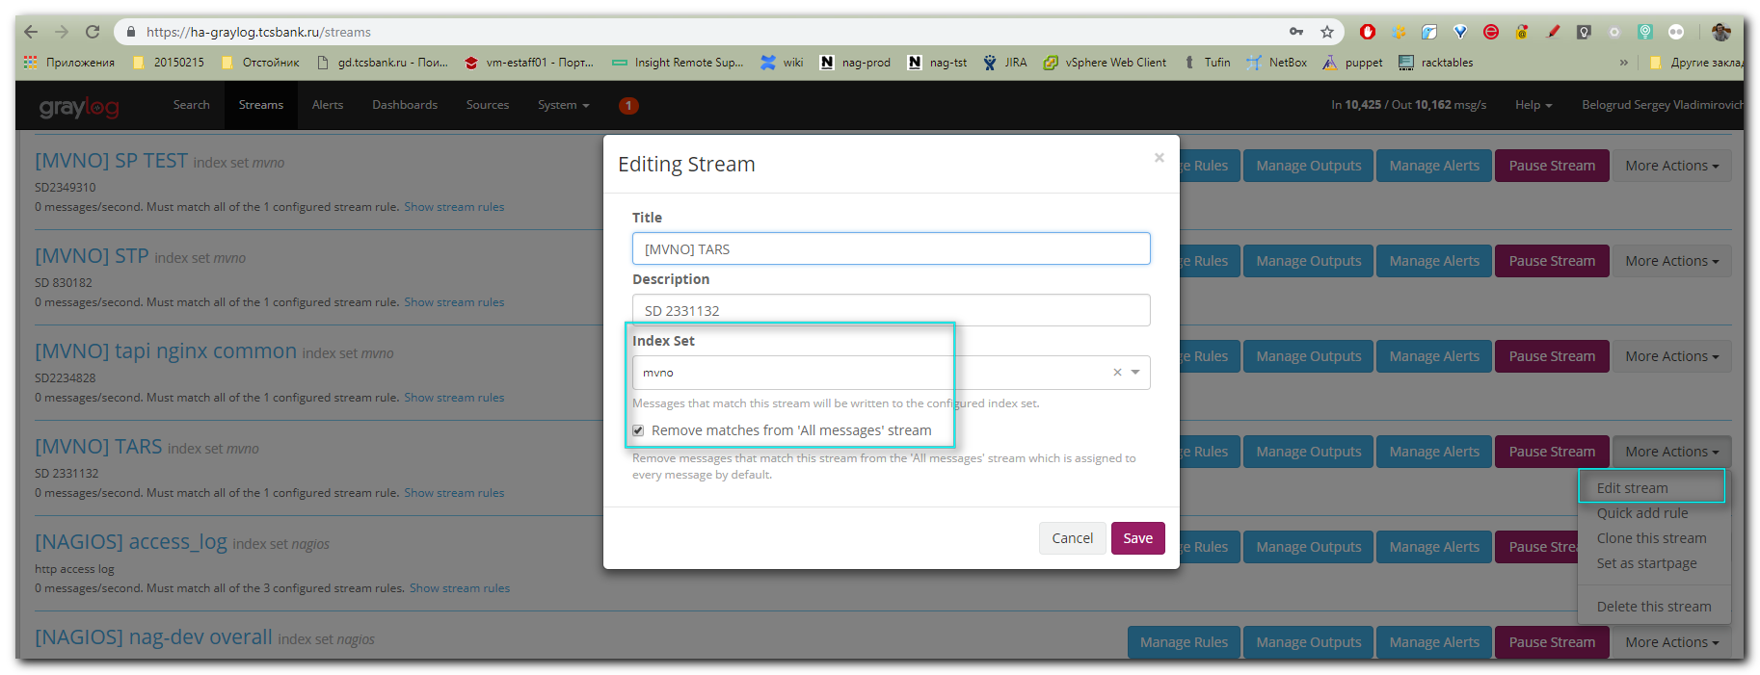

#
# Here are some examples of rules for Stream.
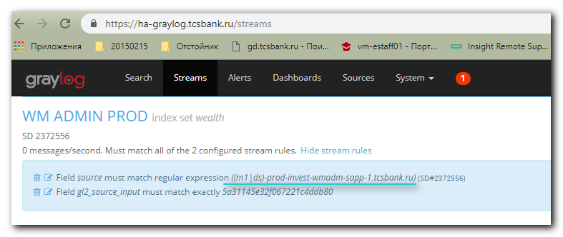
((m1|ds)-prod-invest-wmadm-sapp-1.tcsbank.ru)
((m1|ds)-prod-wema-api-(1|2).tcsbank.ru)
(ost-(qa|dev)-invest-wmadm-sapp-(1|2).prt-api.ds.tinkoff.cloud)
(ost-wema-(qa|dev)-api-(1|2).prt-api.tinkoff.cloud)
((m1|ds)-uat-invest-wmadm-sapp-1)
(vm-uat-wema-api-(1|2).tcsbank.ru)

#
# Information about Input for the Stream is here. And I have no solution, how to find its name
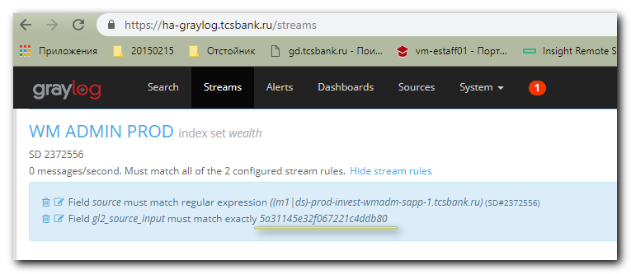

# There is only one way to define Input name, that I know at this moment.
# The method is to find appropriate symbols-digits-code on the page, where all Inputs shows.
# Go here: https://ha-graylog.tcsbank.ru/system/inputs
# Press F12
# Press Ctrl+F
# Print symbols-digits-code in appeared field.
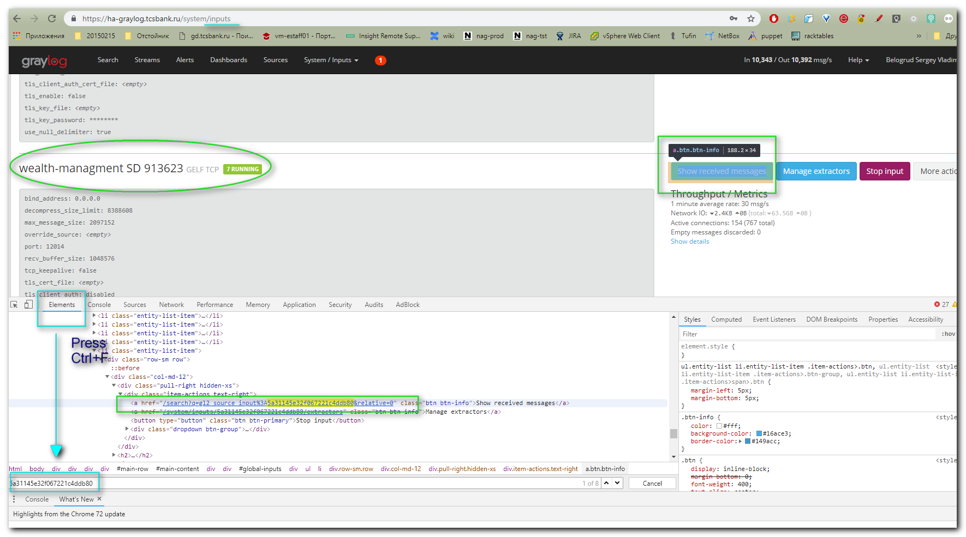

# To to directly to the page, where the Stream’s messages displaying, I can use URL prplacement.
# Use URL like this: https://ha-graylog.tcsbank.ru/search?q=gl2_source_input%3A5877407132f06721a160ebde&relative=0
# Selected fields should be replaced with appropriate ones.

# And replace these fields of URL with appropriate value 5a31145e32f067221c4ddb80 what we are looking for.
# https://ha-graylog.tcsbank.ru/search?q=gl2_source_input%3A5a31145e32f067221c4ddb80&relative=0
# I’ve found the Input, but there is no name of the Input.
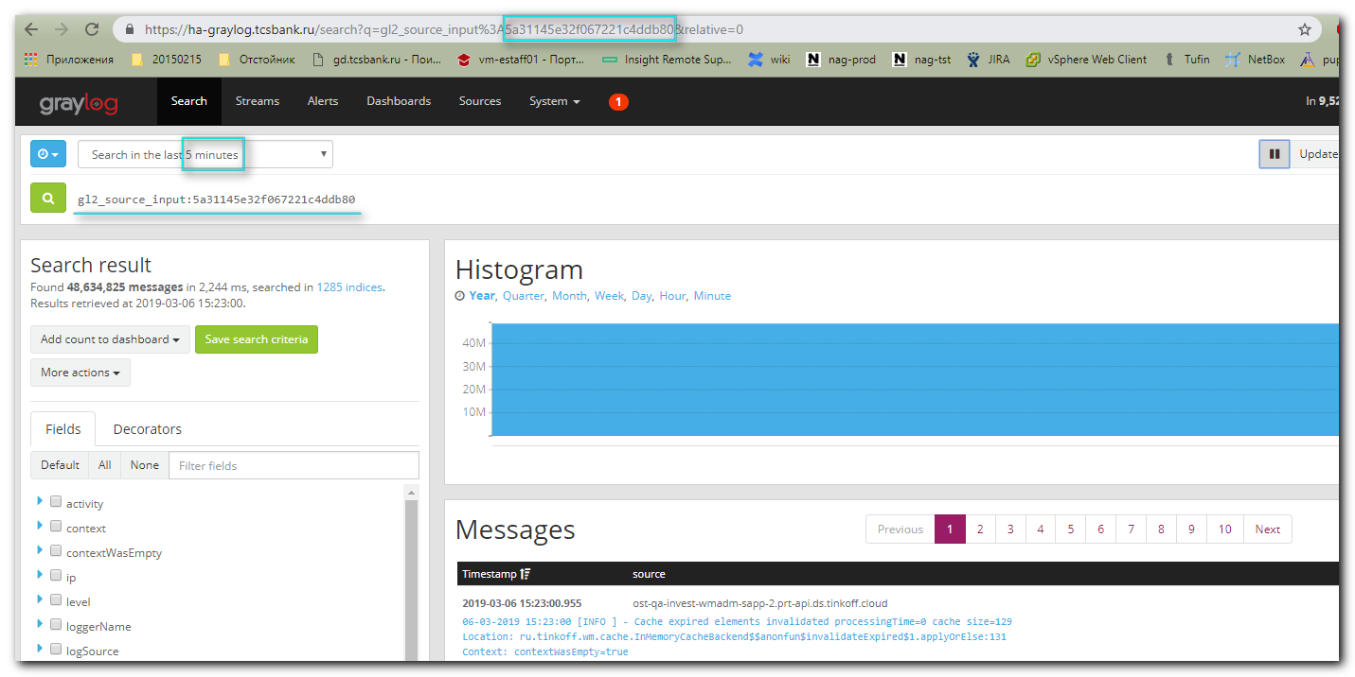
# The result will looks like if I use this web-interface elements and press on the button.
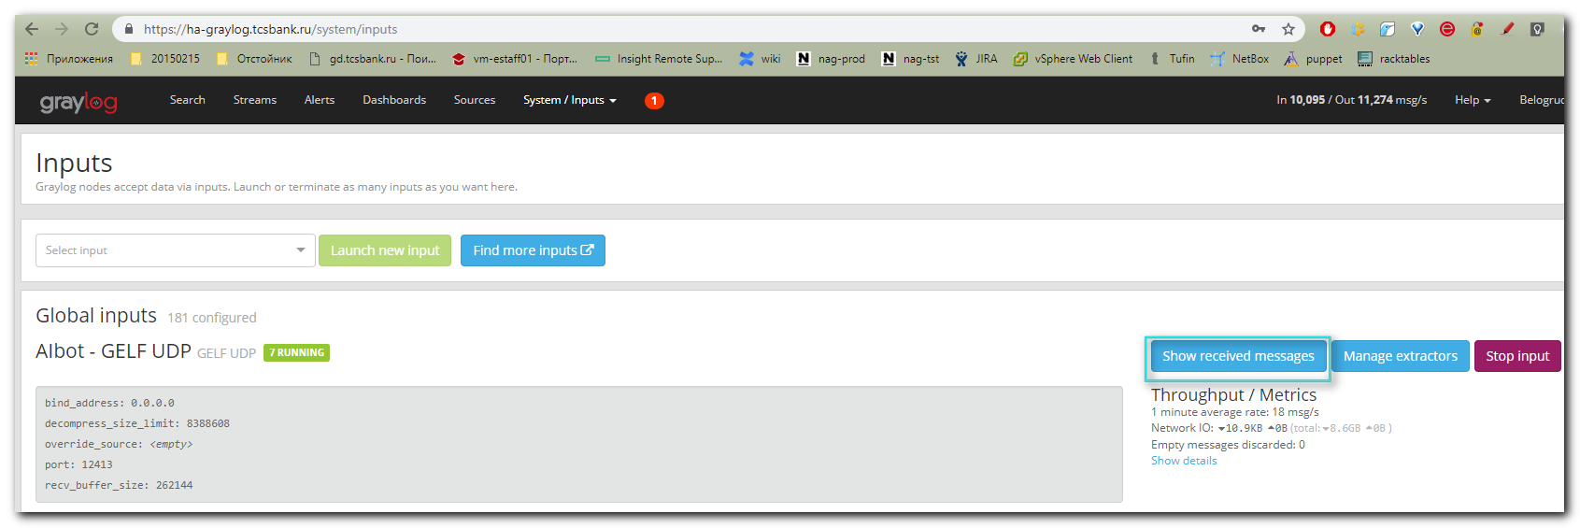
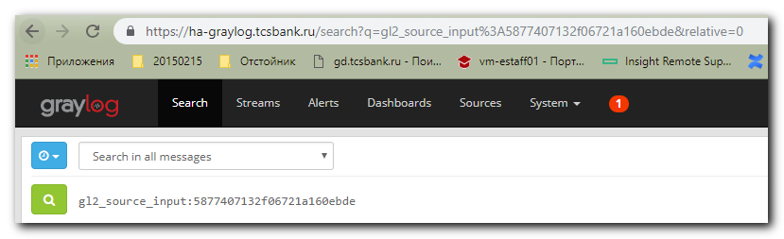

#
# 20190306
#
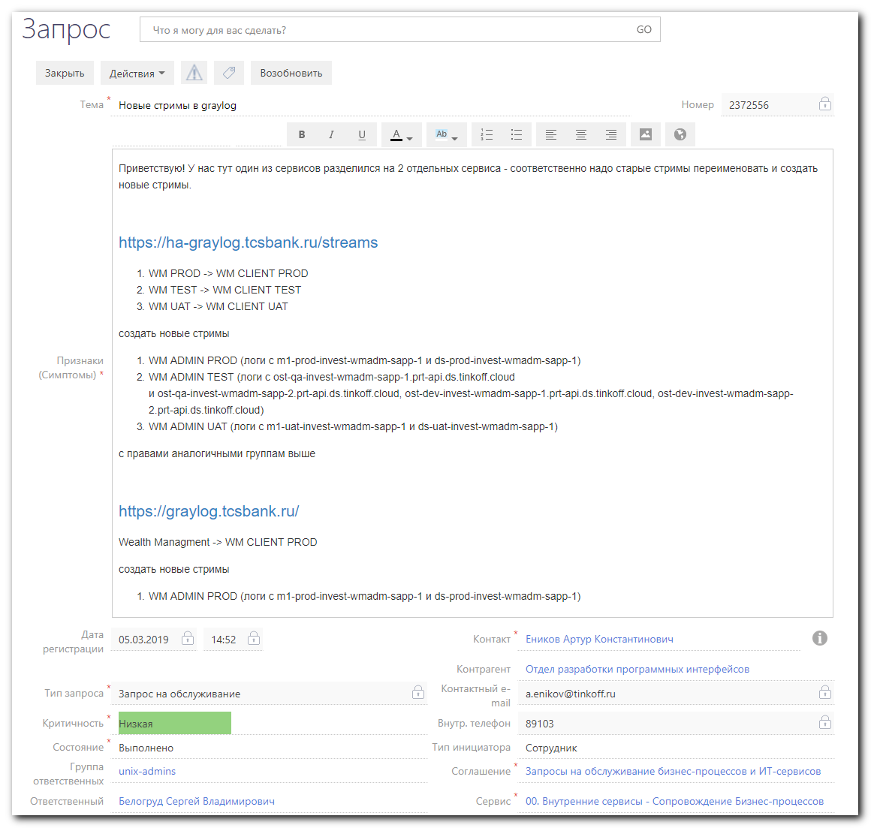
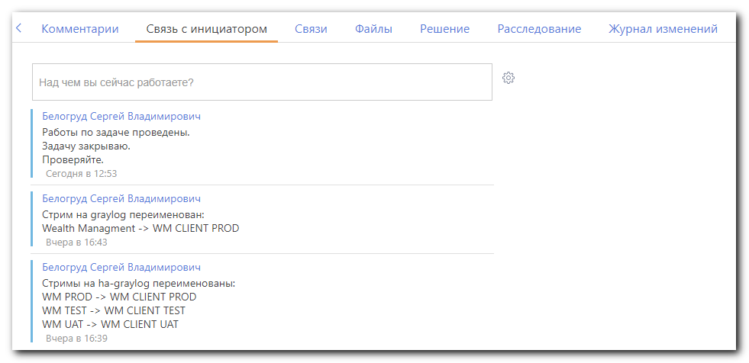

#
# Steps, how this task was done

#
# I have not way to find, what Input name belongs to defined Streams. Only asking for people to show similar Stream, to use it and clone it for new Streams.
#
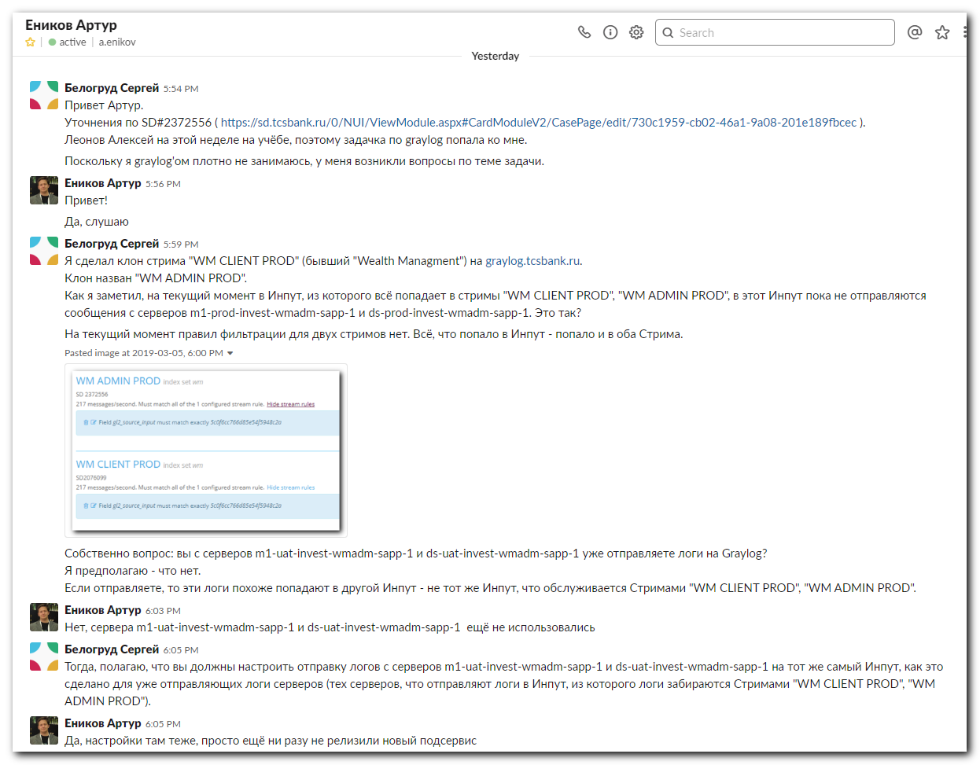
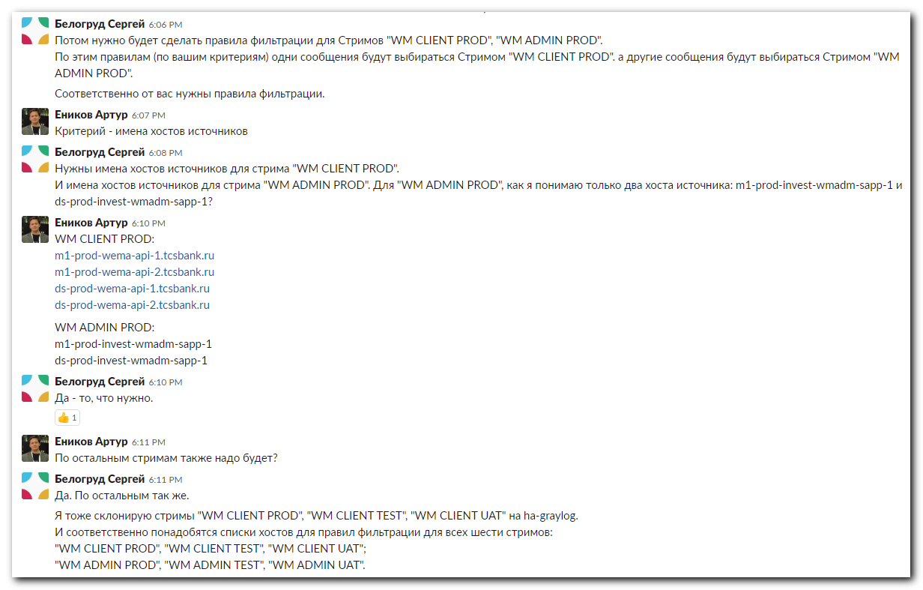
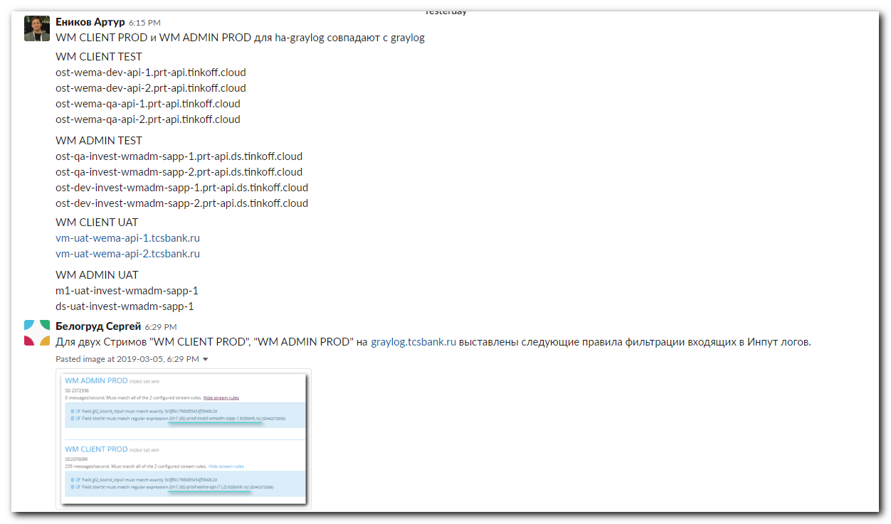
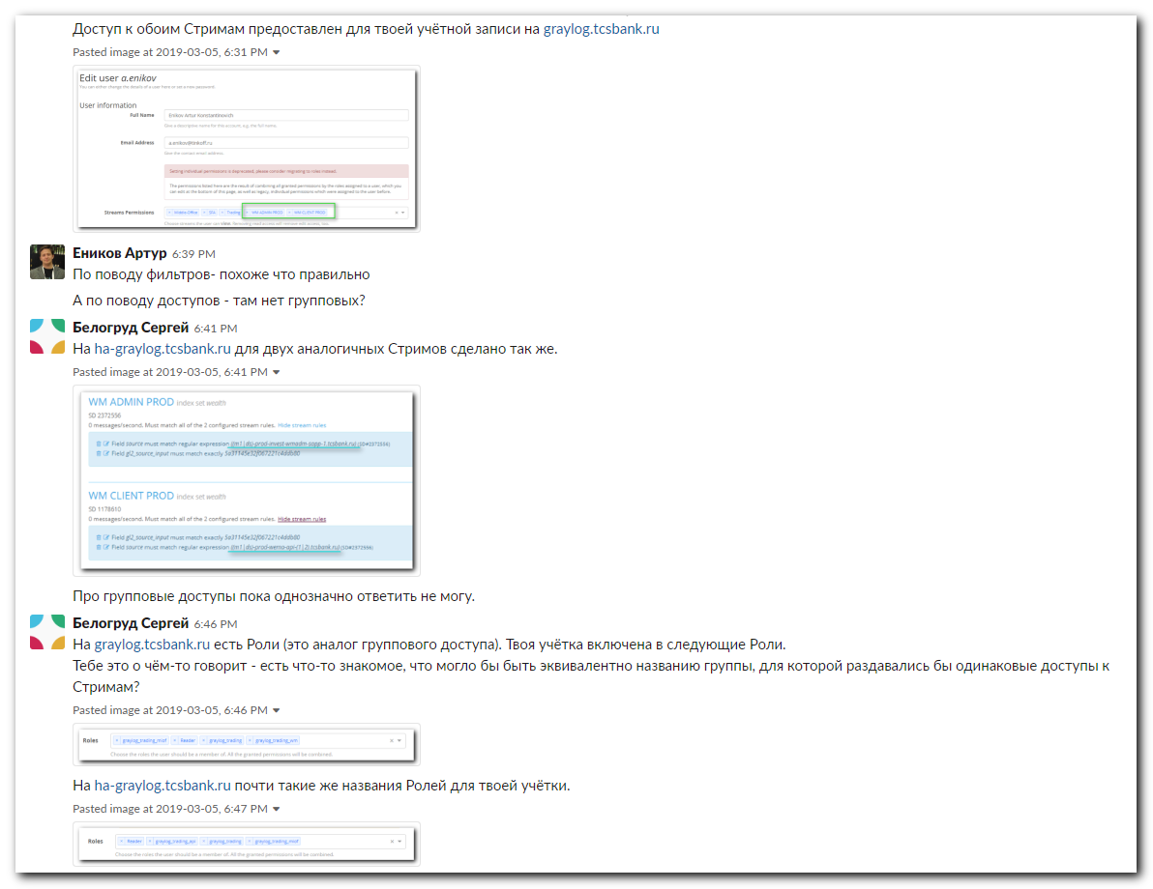
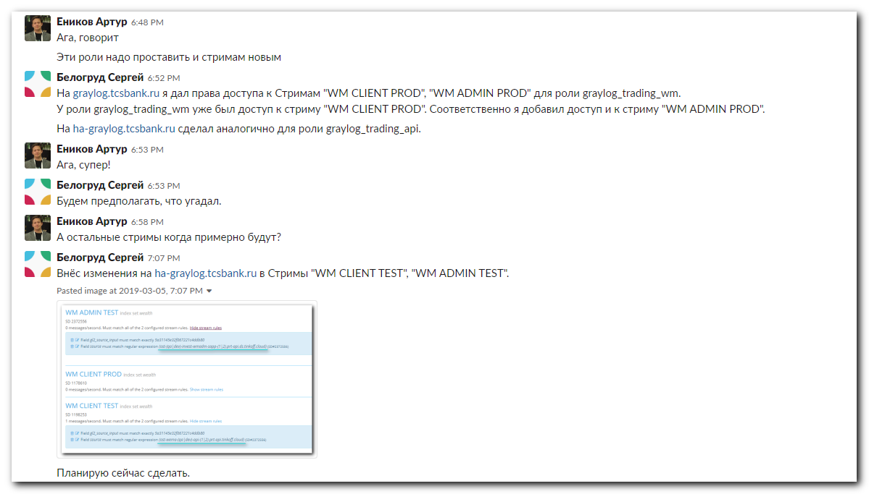
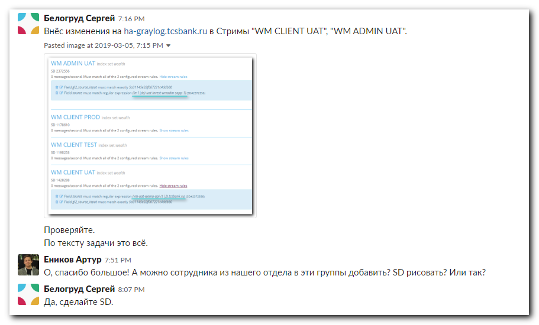

#
# An example of next task.
#
# Here is again - I’ve asked for initiator to inform me about similar Stream to clone it for new Streams.
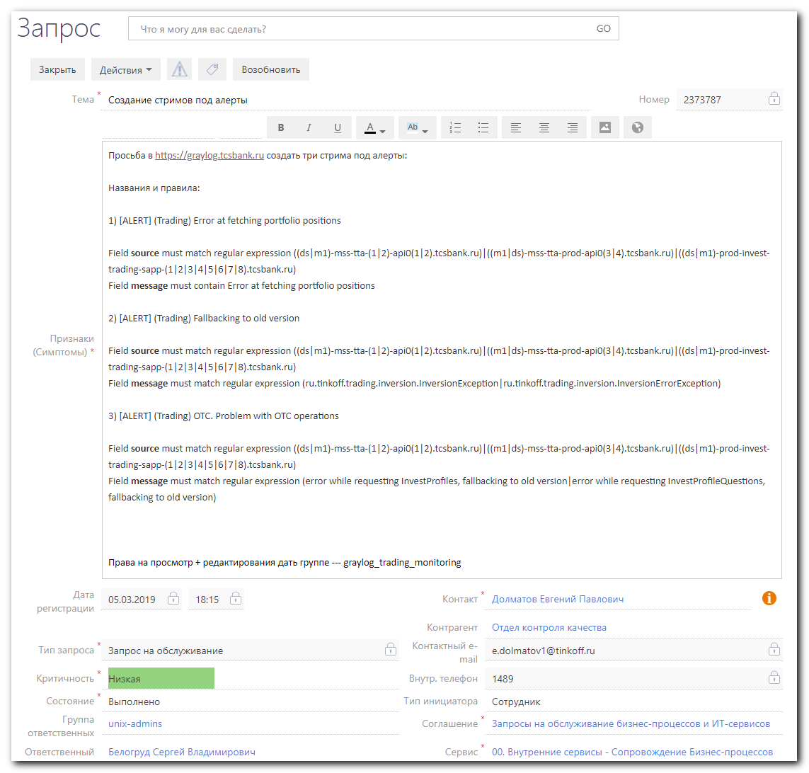
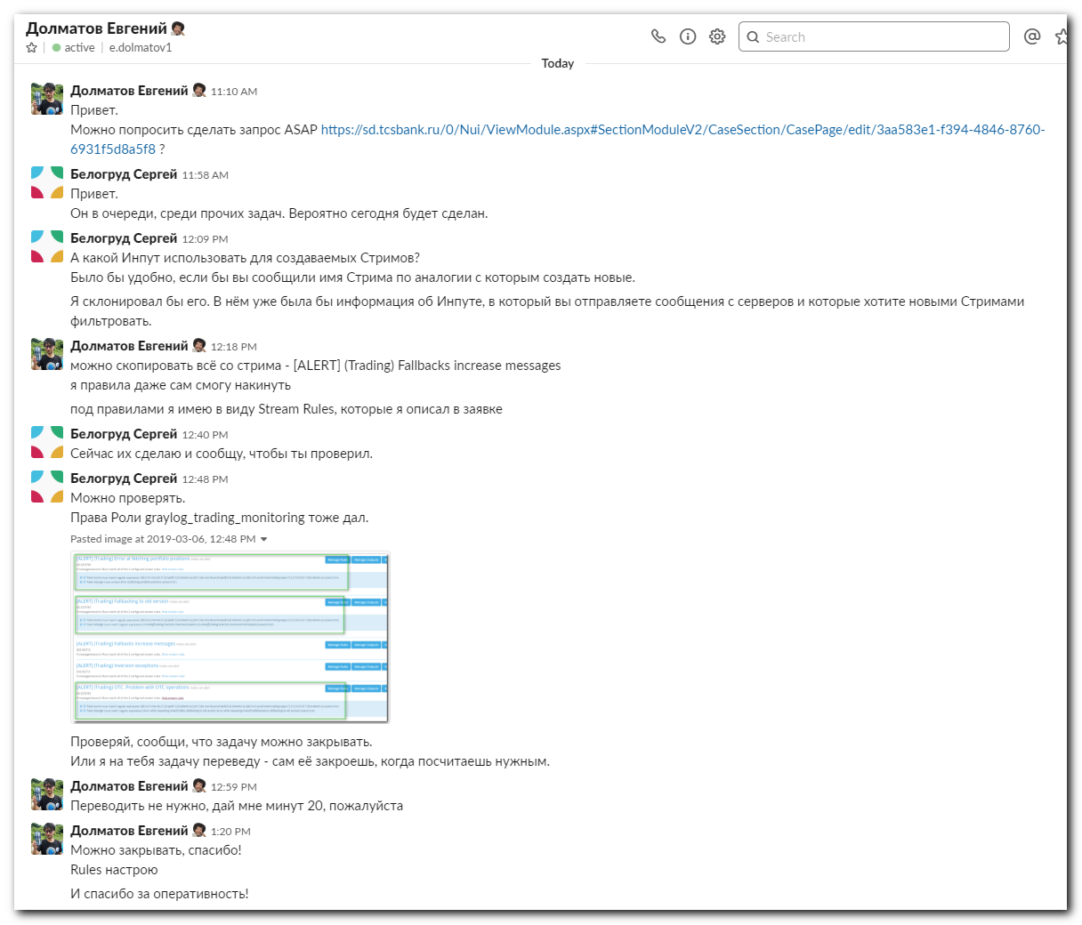

#
#
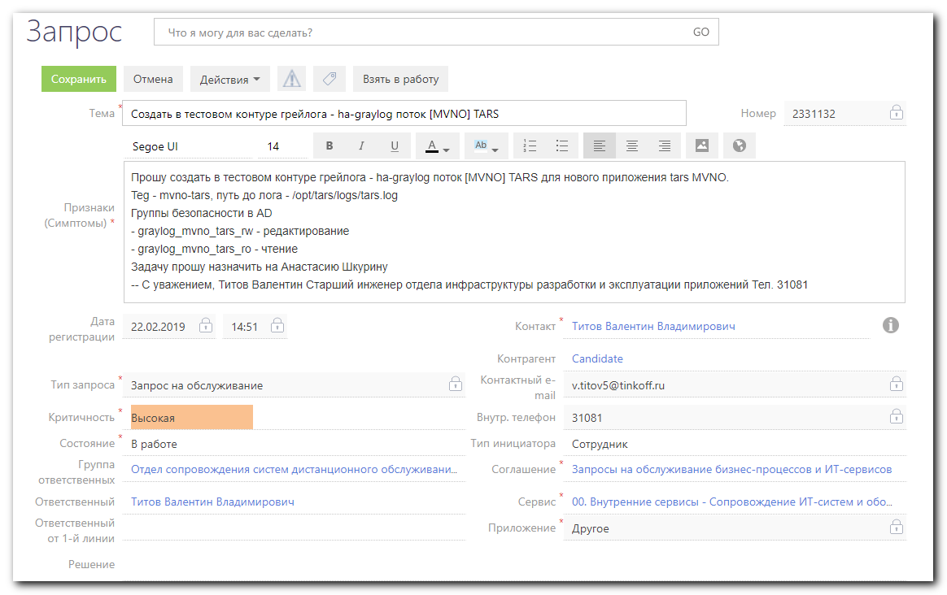
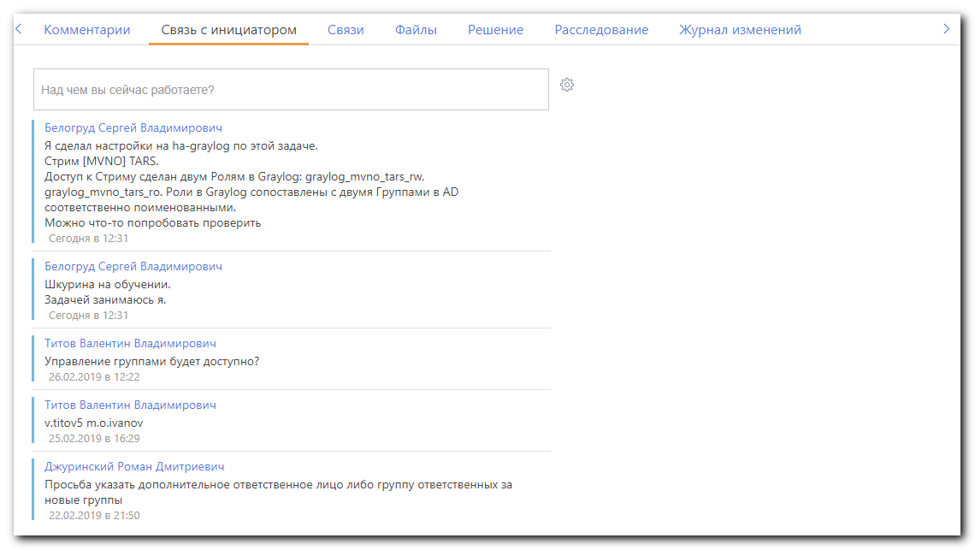

#
# Steps of doing this task.
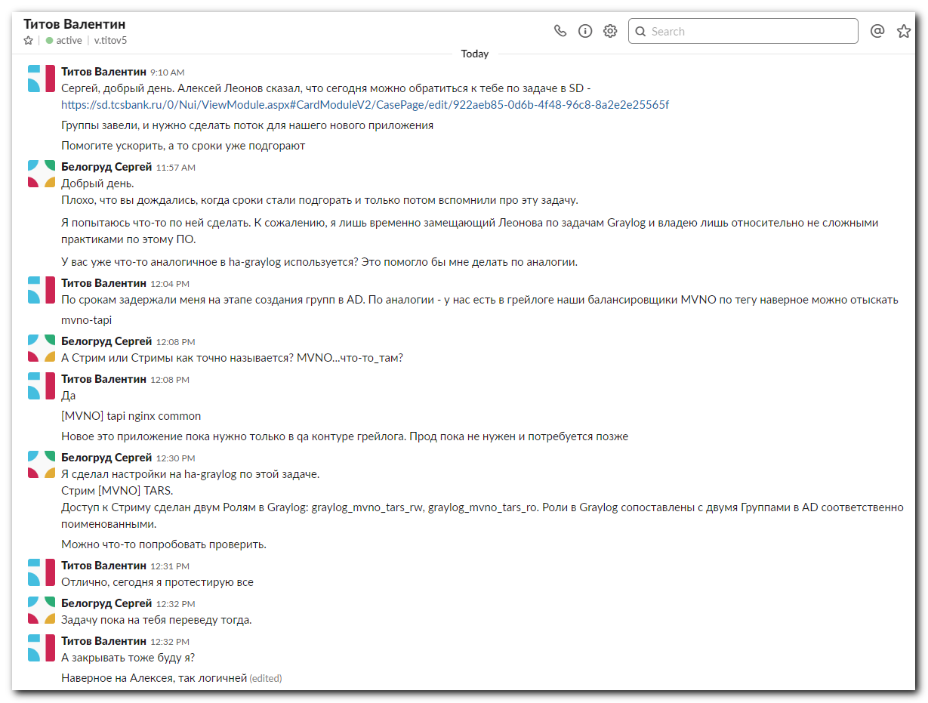
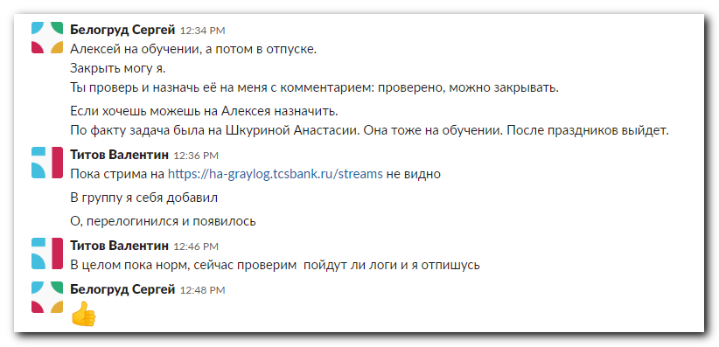

#
#
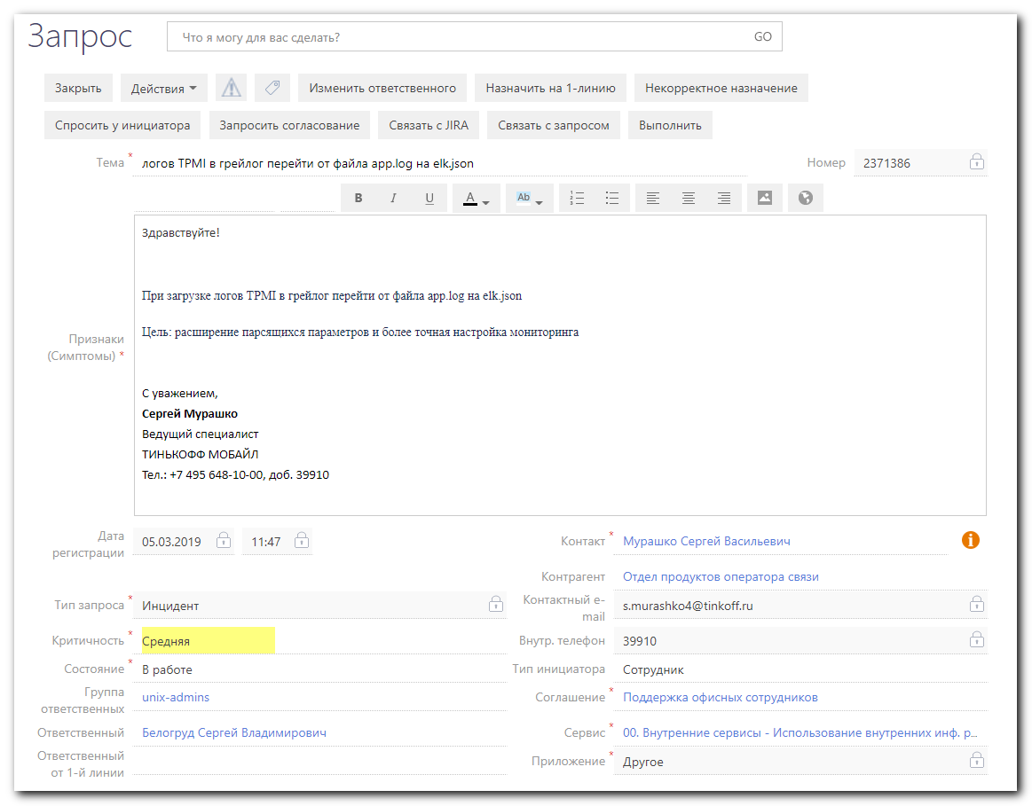
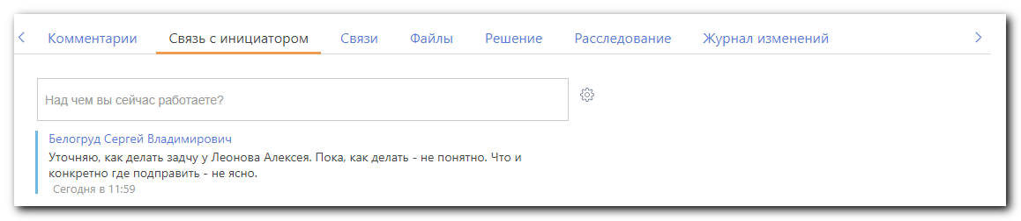
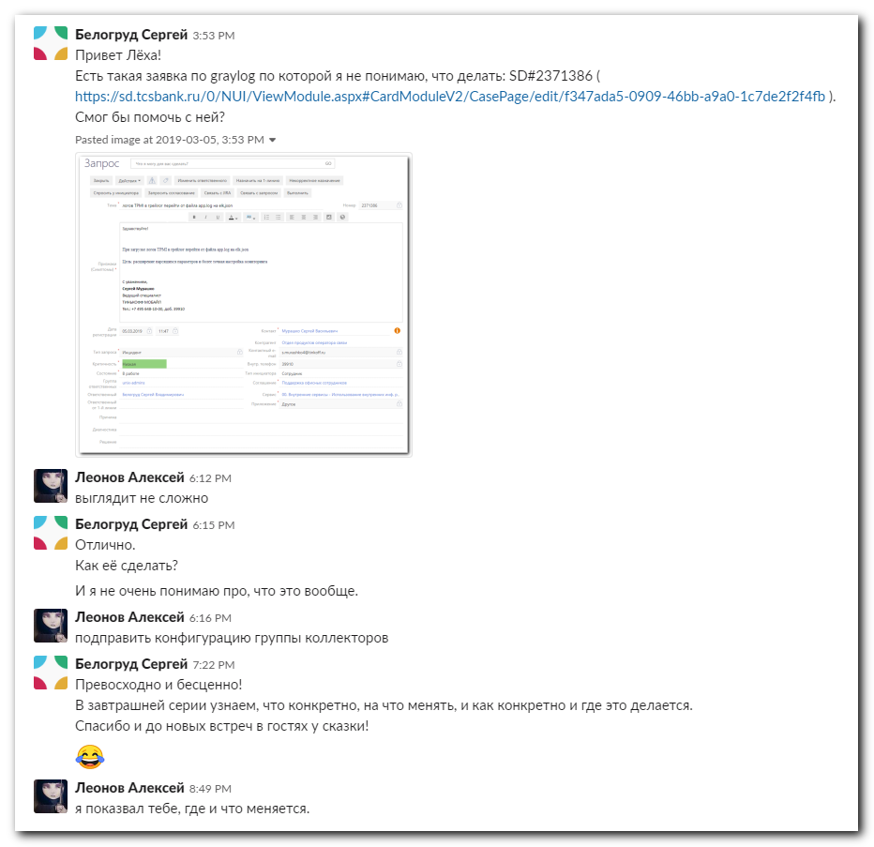

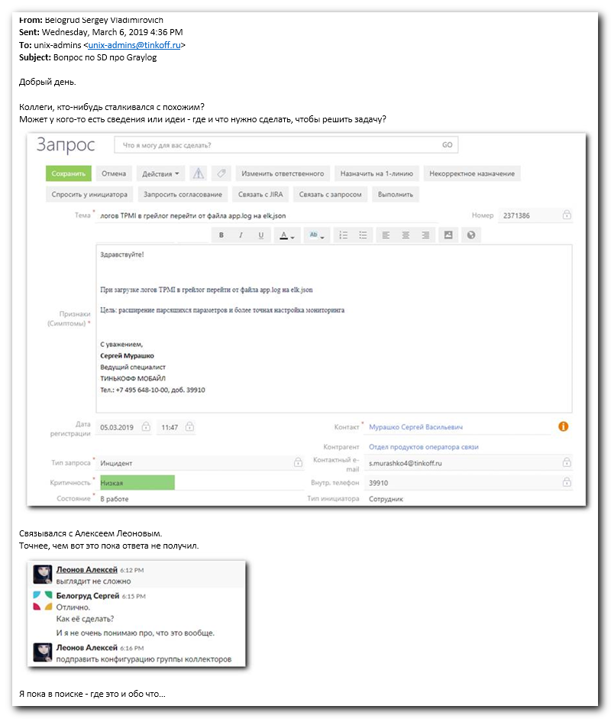
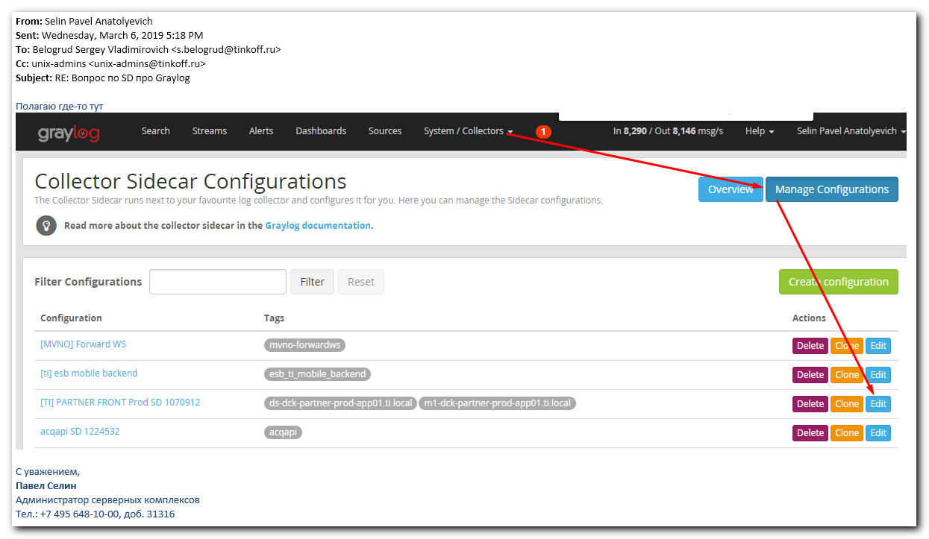

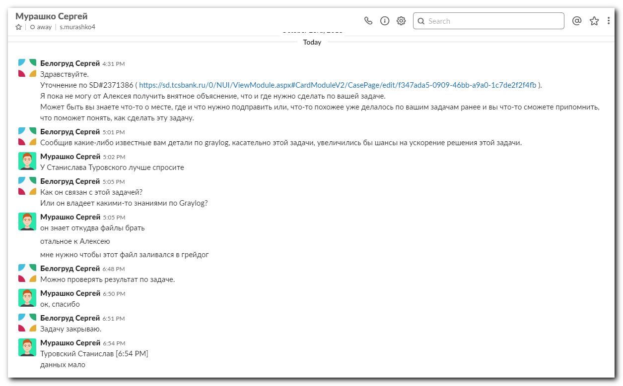

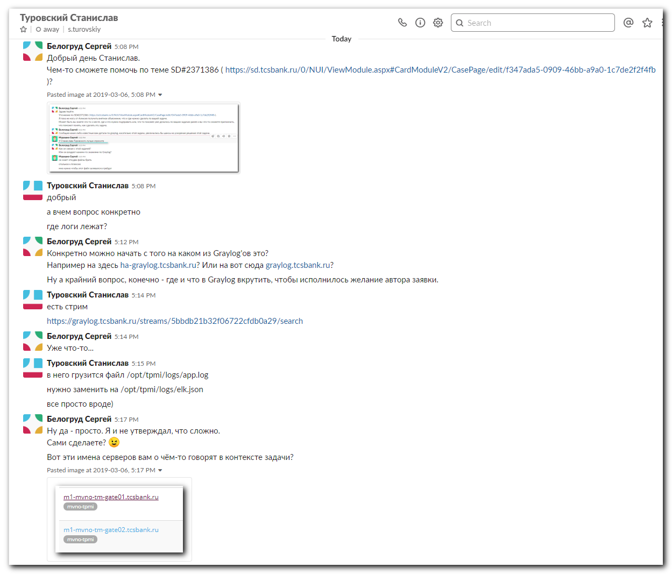
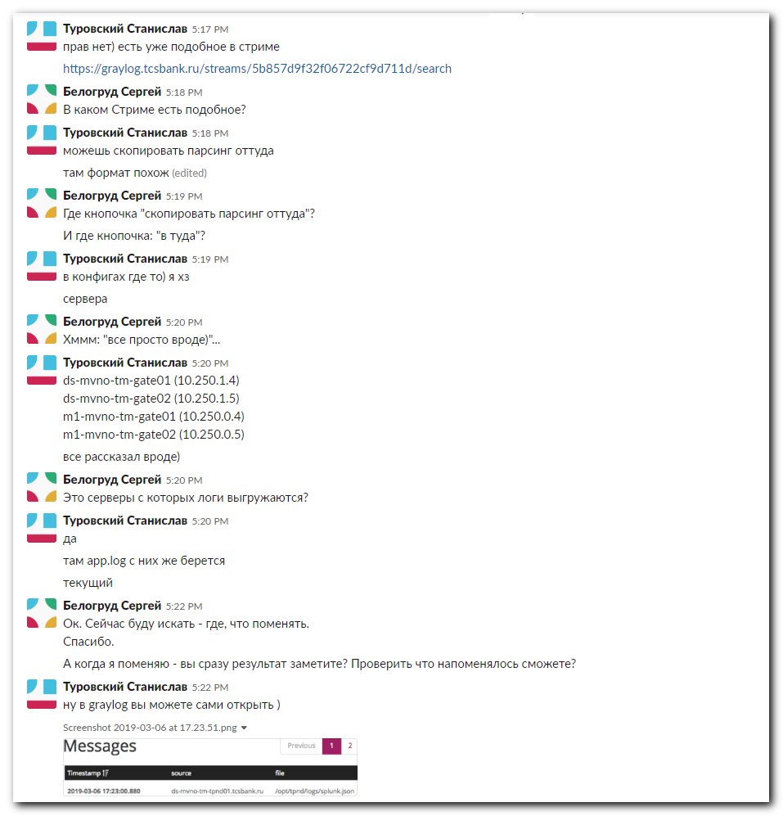
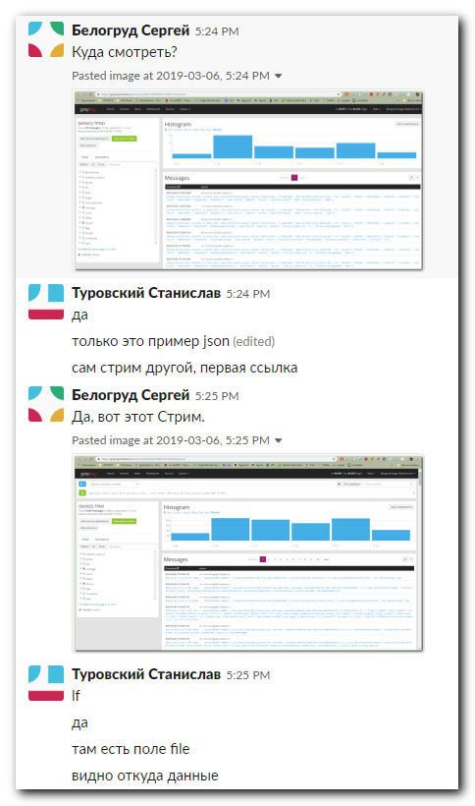
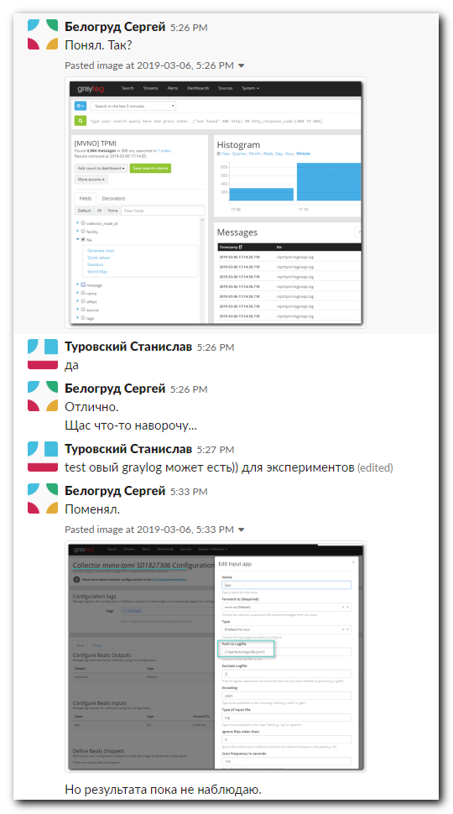
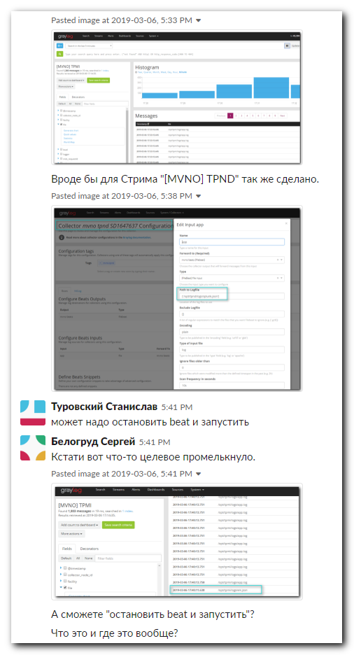
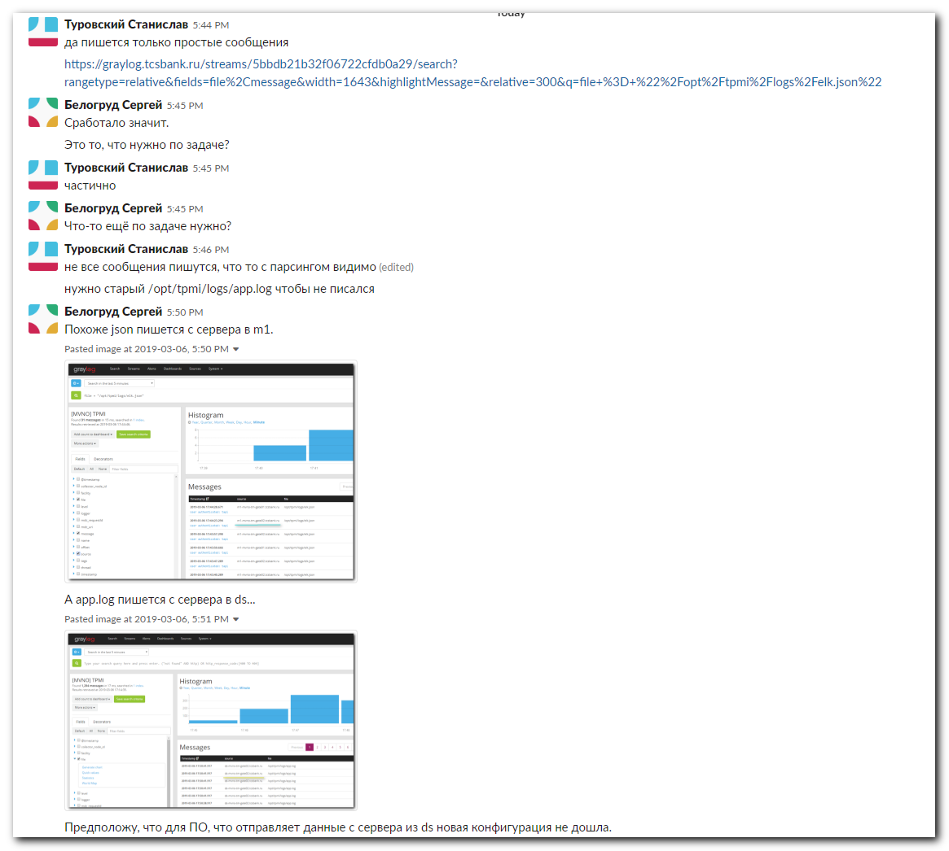
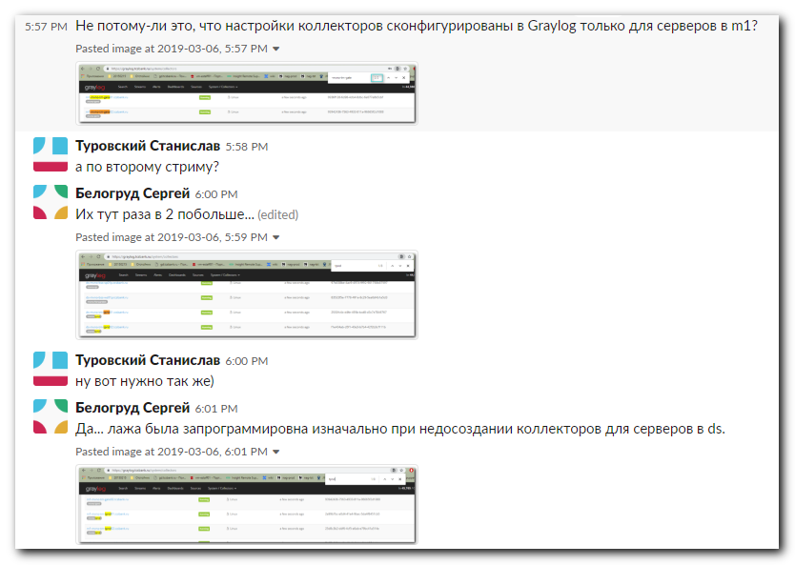
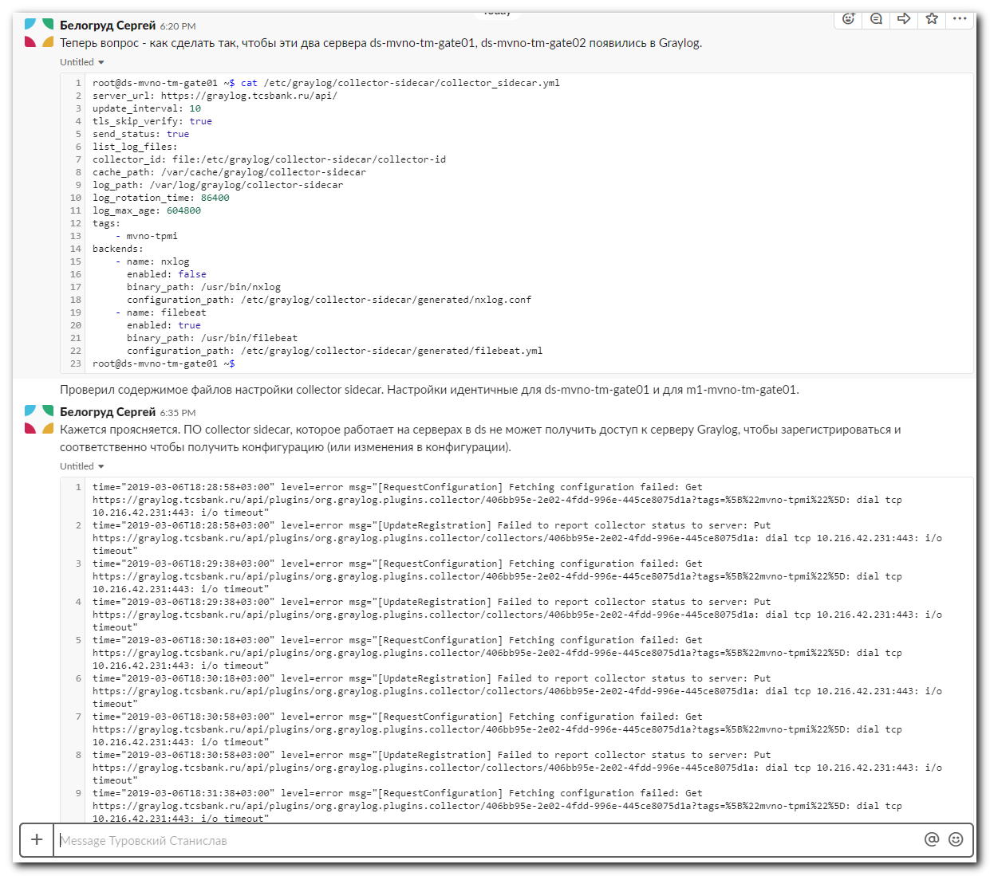
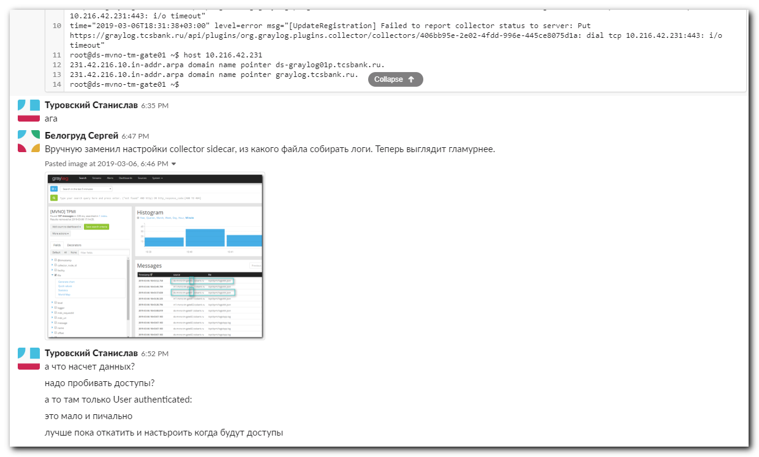

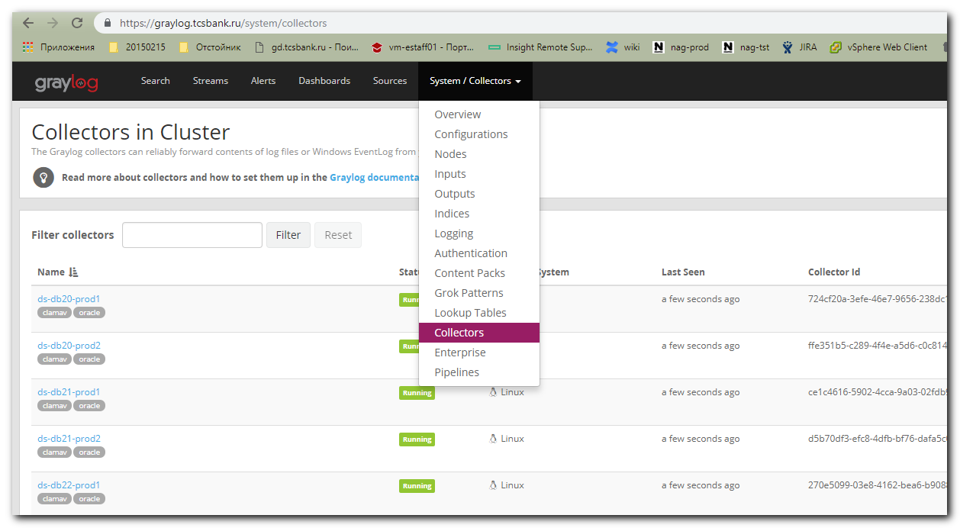

#
# There are only two servers have tag “mvno-tpmi”. Are absent servers ds-...
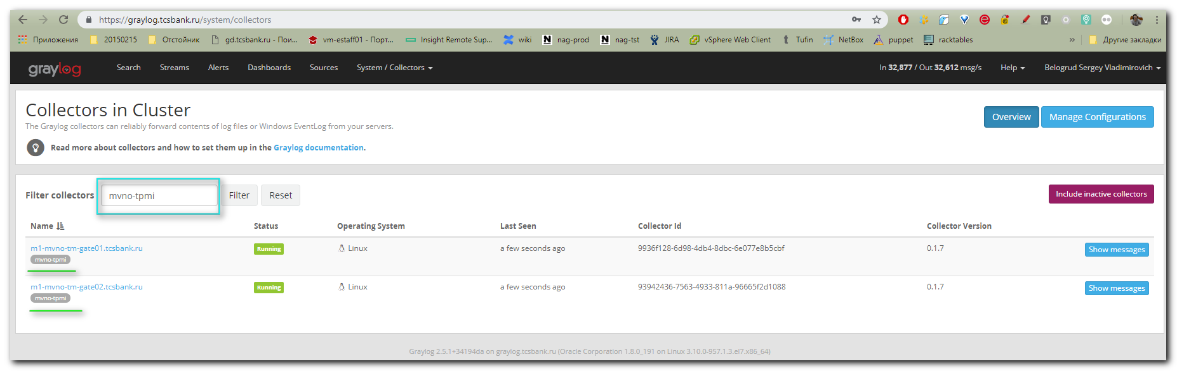

# It have to be like this. It’s a similar shit.
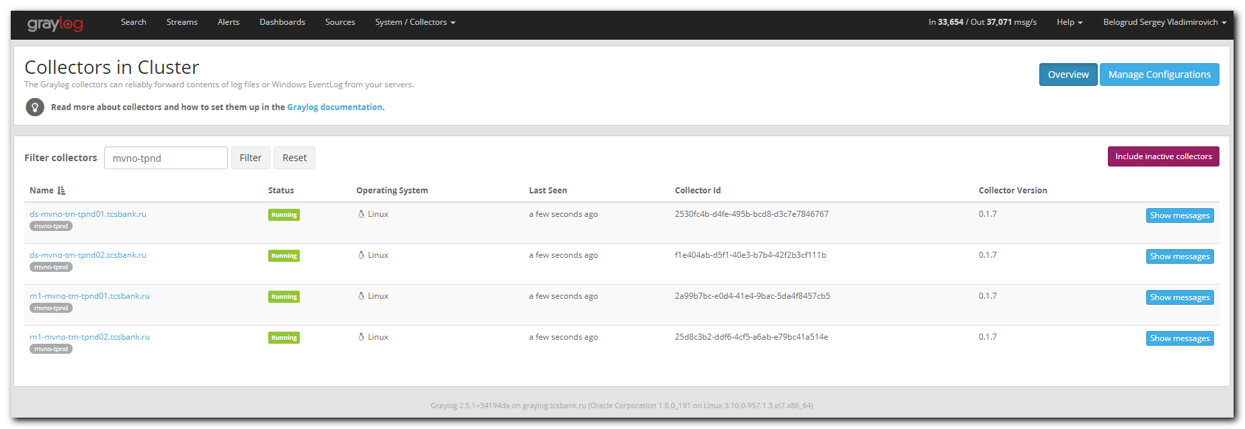

#
# This shoud be changed from app.log to elk.json.
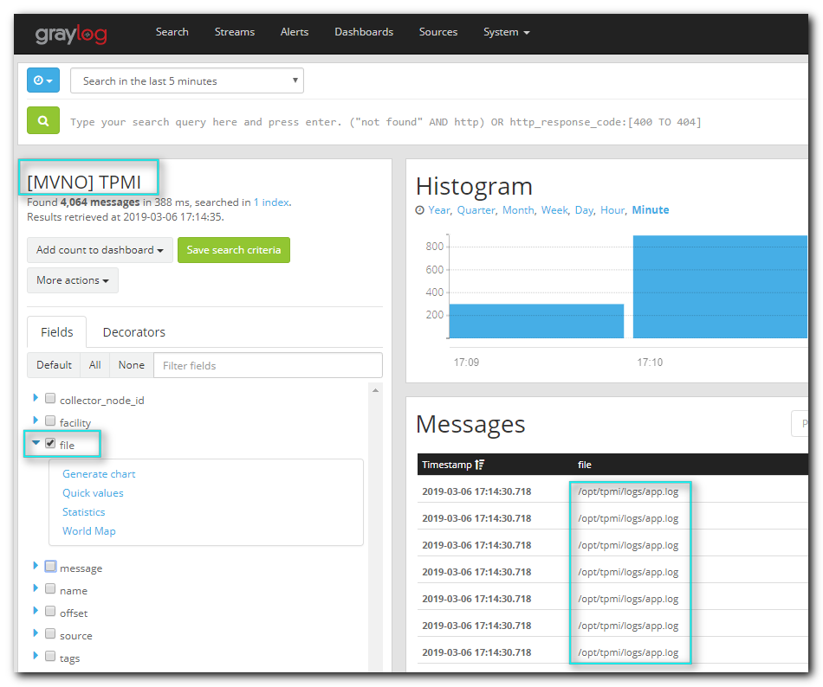

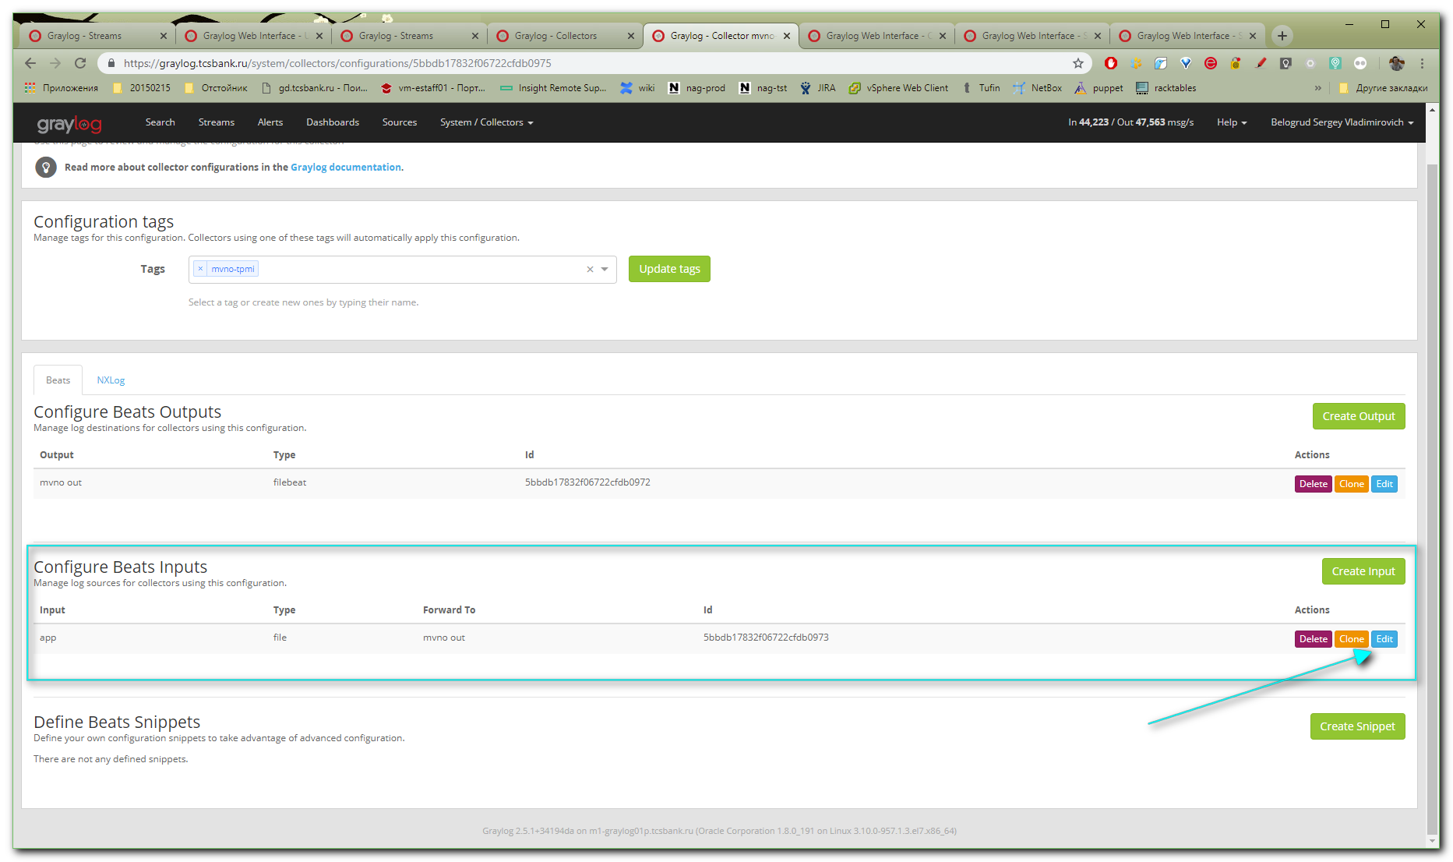

# Here is a place, where to change file path and its name.
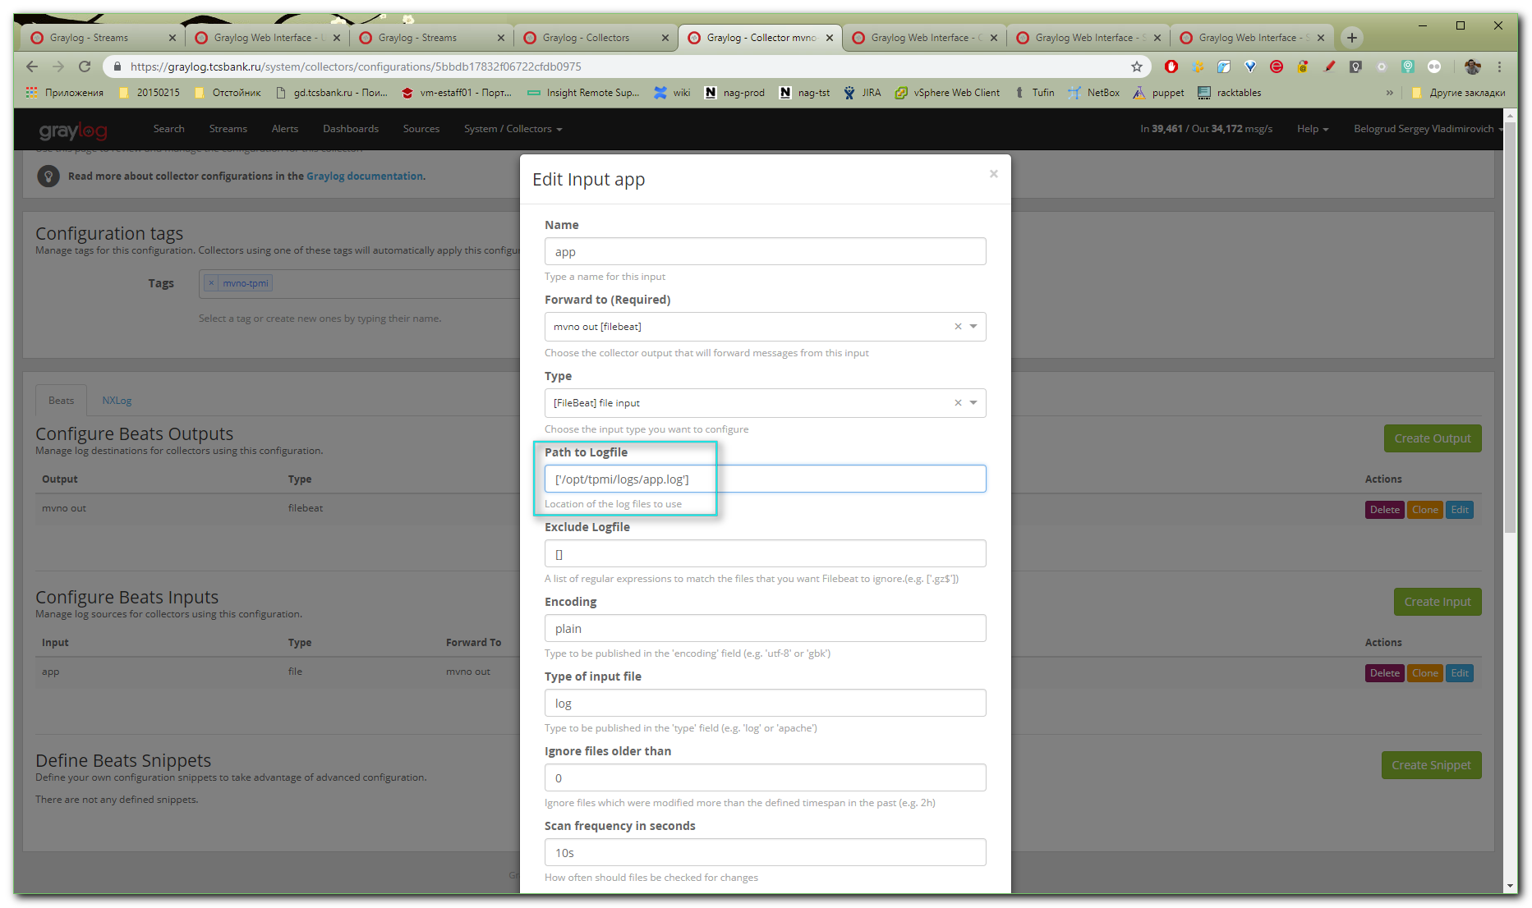
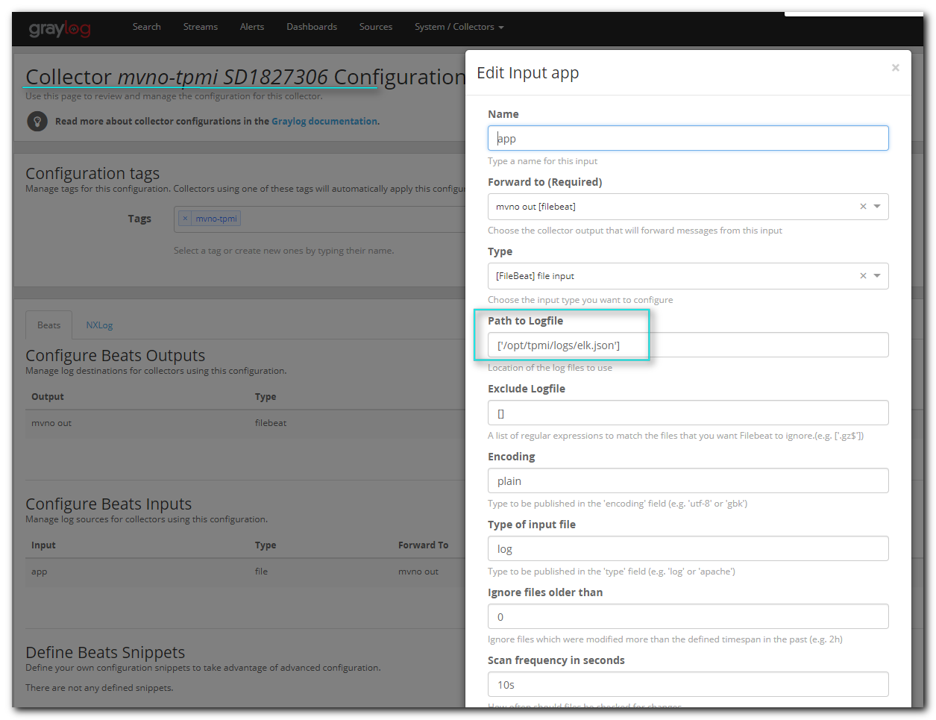

#
# Not changes found, but it’s not true.
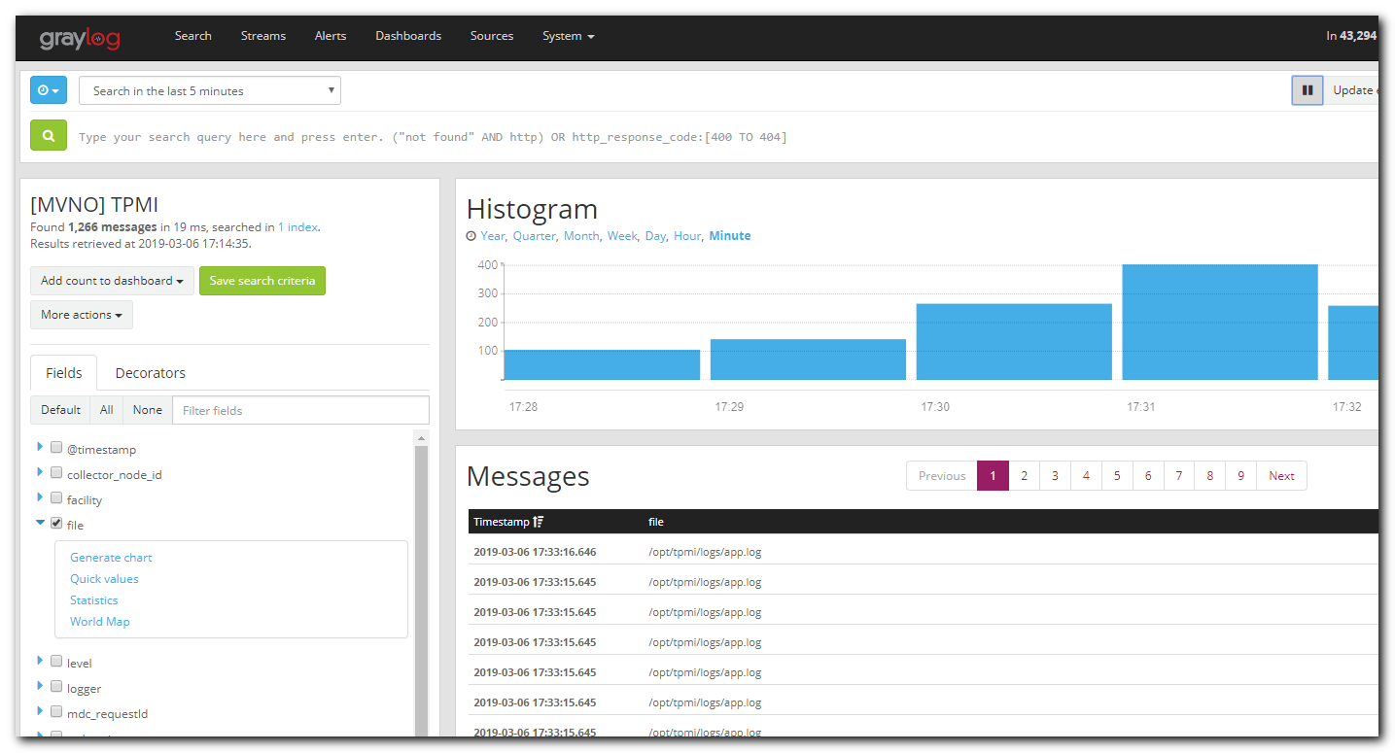
# For servers in m1-... changes were applied.
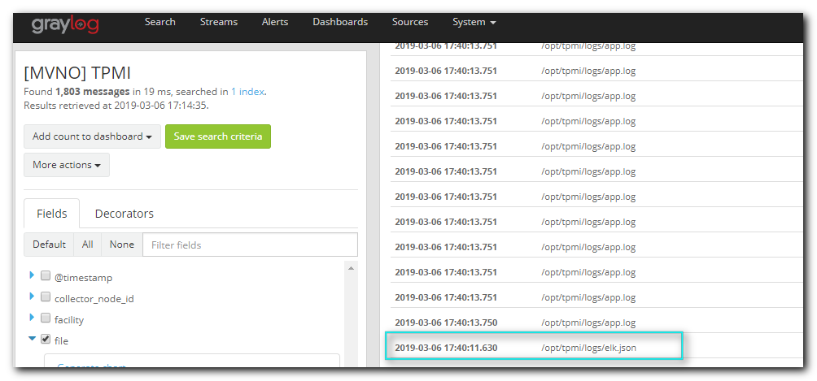
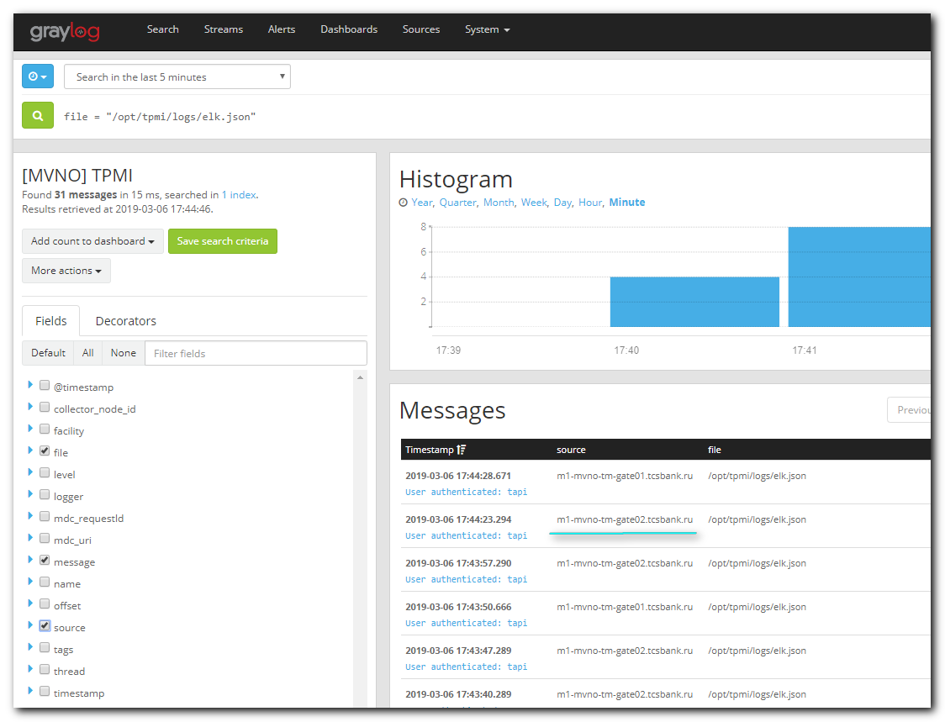

# But for servers in ds-... changes was not applied.
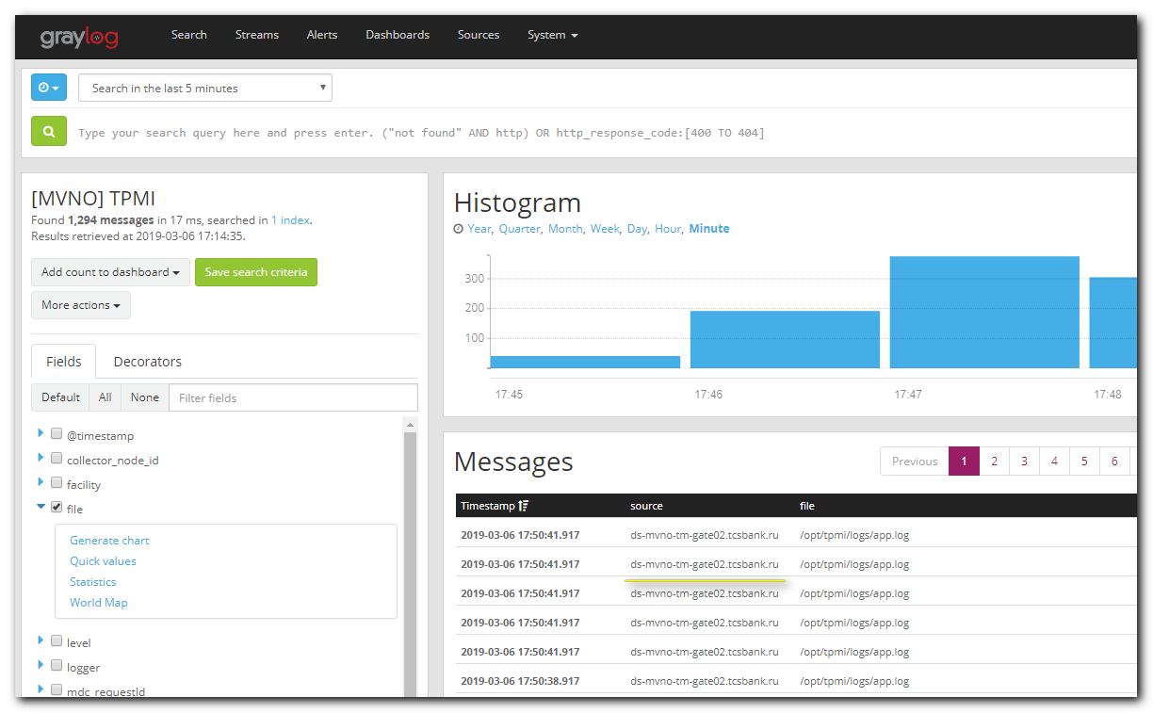

#
# http://docs.graylog.org/en/2.4/pages/collector_sidecar.html
#

root@ds-mvno-tm-gate01 ~$ systemctl list-units --type service | grep -ie "side"
collector-sidecar.service loaded active running Wrapper service for Graylog controlled collector
root@ds-mvno-tm-gate01 ~$ systemctl status collector-sidecar
● collector-sidecar.service - Wrapper service for Graylog controlled collector
Loaded: loaded (/etc/systemd/system/collector-sidecar.service; enabled; vendor preset: disabled)
Active: active (running) since Fri 2018-12-21 14:50:17 MSK; 2 months 14 days ago
Main PID: 22021 (graylog-collect)
Tasks: 34
Memory: 133.4M
CGroup: /system.slice/collector-sidecar.service
├─22021 /usr/bin/graylog-collector-sidecar
└─22099 /usr/bin/filebeat -c /etc/graylog/collector-sidecar/generated/filebeat.yml

Mar 06 18:12:04 ds-mvno-tm-gate01.tcsbank.ru graylog-collector-sidecar[22021]: time="2019-03-06T18:12:04+03:00" level=error msg="[RequestConfiguration] Fetching configuration failed: Get https://g...o timeout"
Mar 06 18:12:10 ds-mvno-tm-gate01.tcsbank.ru graylog-collector-sidecar[22021]: time="2019-03-06T18:12:10+03:00" level=error msg="[UpdateRegistration] Failed to report collector status to server: P...o timeout"
Mar 06 18:12:44 ds-mvno-tm-gate01.tcsbank.ru graylog-collector-sidecar[22021]: time="2019-03-06T18:12:44+03:00" level=error msg="[RequestConfiguration] Fetching configuration failed: Get https://g...o timeout"
Mar 06 18:12:50 ds-mvno-tm-gate01.tcsbank.ru graylog-collector-sidecar[22021]: time="2019-03-06T18:12:50+03:00" level=error msg="[UpdateRegistration] Failed to report collector status to server: P...o timeout"
Mar 06 18:13:24 ds-mvno-tm-gate01.tcsbank.ru graylog-collector-sidecar[22021]: time="2019-03-06T18:13:24+03:00" level=error msg="[RequestConfiguration] Fetching configuration failed: Get https://g...o timeout"
Mar 06 18:13:30 ds-mvno-tm-gate01.tcsbank.ru graylog-collector-sidecar[22021]: time="2019-03-06T18:13:30+03:00" level=error msg="[UpdateRegistration] Failed to report collector status to server: P...o timeout"
Mar 06 18:14:04 ds-mvno-tm-gate01.tcsbank.ru graylog-collector-sidecar[22021]: time="2019-03-06T18:14:04+03:00" level=error msg="[RequestConfiguration] Fetching configuration failed: Get https://g...o timeout"
Mar 06 18:14:10 ds-mvno-tm-gate01.tcsbank.ru graylog-collector-sidecar[22021]: time="2019-03-06T18:14:10+03:00" level=error msg="[UpdateRegistration] Failed to report collector status to server: P...o timeout"
Mar 06 18:14:44 ds-mvno-tm-gate01.tcsbank.ru graylog-collector-sidecar[22021]: time="2019-03-06T18:14:44+03:00" level=error msg="[RequestConfiguration] Fetching configuration failed: Get https://g...o timeout"
Mar 06 18:14:50 ds-mvno-tm-gate01.tcsbank.ru graylog-collector-sidecar[22021]: time="2019-03-06T18:14:50+03:00" level=error msg="[UpdateRegistration] Failed to report collector status to server: P...o timeout"
Hint: Some lines were ellipsized, use -l to show in full.
root@ds-mvno-tm-gate01 ~$

root@ds-mvno-tm-gate01 ~$ systemctl restart collector-sidecar
root@ds-mvno-tm-gate01 ~$ systemctl status collector-sidecar
● collector-sidecar.service - Wrapper service for Graylog controlled collector
Loaded: loaded (/etc/systemd/system/collector-sidecar.service; enabled; vendor preset: disabled)
Active: active (running) since Wed 2019-03-06 18:15:24 MSK; 7s ago
Main PID: 5602 (graylog-collect)
Tasks: 20
Memory: 21.9M
CGroup: /system.slice/collector-sidecar.service
├─5602 /usr/bin/graylog-collector-sidecar
└─5634 /usr/bin/filebeat -c /etc/graylog/collector-sidecar/generated/filebeat.yml

Mar 06 18:15:24 ds-mvno-tm-gate01.tcsbank.ru systemd[1]: Started Wrapper service for Graylog controlled collector.
Mar 06 18:15:24 ds-mvno-tm-gate01.tcsbank.ru systemd[1]: Starting Wrapper service for Graylog controlled collector...
Mar 06 18:15:24 ds-mvno-tm-gate01.tcsbank.ru graylog-collector-sidecar[5602]: time="2019-03-06T18:15:24+03:00" level=info msg="Using collector-id: 406bb95e-2e02-4fdd-996e-445ce8075d1a"
Mar 06 18:15:24 ds-mvno-tm-gate01.tcsbank.ru graylog-collector-sidecar[5602]: time="2019-03-06T18:15:24+03:00" level=info msg="No node-id was configured, falling back to hostname"
Mar 06 18:15:24 ds-mvno-tm-gate01.tcsbank.ru graylog-collector-sidecar[5602]: time="2019-03-06T18:15:24+03:00" level=info msg="Fetching configurations tagged by: [mvno-tpmi]"
Mar 06 18:15:24 ds-mvno-tm-gate01.tcsbank.ru graylog-collector-sidecar[5602]: time="2019-03-06T18:15:24+03:00" level=info msg="Starting signal distributor"
Mar 06 18:15:24 ds-mvno-tm-gate01.tcsbank.ru graylog-collector-sidecar[5602]: time="2019-03-06T18:15:24+03:00" level=info msg="[filebeat] Starting (exec driver)"
root@ds-mvno-tm-gate01 ~$

root@ds-mvno-tm-gate01 ~$ cat /etc/graylog/collector-sidecar/collector_sidecar.yml
server_url: https://graylog.tcsbank.ru/api/
update_interval: 10
tls_skip_verify: true
send_status: true
list_log_files:
collector_id: file:/etc/graylog/collector-sidecar/collector-id
cache_path: /var/cache/graylog/collector-sidecar
log_path: /var/log/graylog/collector-sidecar
log_rotation_time: 86400
log_max_age: 604800
tags:
- mvno-tpmi
backends:
- name: nxlog
enabled: false
binary_path: /usr/bin/nxlog
configuration_path: /etc/graylog/collector-sidecar/generated/nxlog.conf
- name: filebeat
enabled: true
binary_path: /usr/bin/filebeat
configuration_path: /etc/graylog/collector-sidecar/generated/filebeat.yml
root@ds-mvno-tm-gate01 ~$

#
# Not changed to appropriate value.
root@ds-mvno-tm-gate01 ~$ cat /etc/graylog/collector-sidecar/generated/filebeat.yml [101/4505]
filebeat:
prospectors:
- encoding: plain
exclude_files: []
fields:
collector_node_id: ds-mvno-tm-gate01.tcsbank.ru
gl2_source_collector: 406bb95e-2e02-4fdd-996e-445ce8075d1a
type: log
ignore_older: 0
multiline:
match: after
negate: true
pattern: ^\d\d\d\d-\d\d-\d\d\ \d\d\:\d\d\:\d\d\.\d\d\d
paths:
- /opt/tpmi/logs/app.log
scan_frequency: 10s
tail_files: true
type: log
output:
logstash:
hosts:
- ha-graylog.tcsbank.ru:12624
path:
data: /var/cache/graylog/collector-sidecar/filebeat/data
logs: /var/log/graylog/collector-sidecar
tags:
- mvno-tpmi
root@ds-mvno-tm-gate01 ~$

# Here I see - no new configuration fetched from graylog server for this collector sidecar.
root@ds-mvno-tm-gate01 ~$ mkdir -p ~/work/20190306-1827
root@ds-mvno-tm-gate01 ~$ cp /etc/graylog/collector-sidecar/generated/filebeat.yml ~/work/20190306-1827/
root@ds-mvno-tm-gate01 ~$ systemctl stop collector-sidecar
root@ds-mvno-tm-gate01 ~$ rm /etc/graylog/collector-sidecar/generated/filebeat.yml
rm: remove regular file ‘/etc/graylog/collector-sidecar/generated/filebeat.yml’? y
root@ds-mvno-tm-gate01 ~$ systemctl start collector-sidecar
root@ds-mvno-tm-gate01 ~$ cat /etc/graylog/collector-sidecar/generated/filebeat.yml
cat: /etc/graylog/collector-sidecar/generated/filebeat.yml: No such file or directory
root@ds-mvno-tm-gate01 ~$ cat /etc/graylog/collector-sidecar/generated/filebeat.yml
cat: /etc/graylog/collector-sidecar/generated/filebeat.yml: No such file or directory
root@ds-mvno-tm-gate01 ~$

#
# There is no access from this server to Graylog to get configuration for collector sidecar.
root@ds-mvno-tm-gate01 ~$ systemctl status collector-sidecar
● collector-sidecar.service - Wrapper service for Graylog controlled collector
Loaded: loaded (/etc/systemd/system/collector-sidecar.service; enabled; vendor preset: disabled)
Active: active (running) since Wed 2019-03-06 18:28:18 MSK; 54s ago
Main PID: 7439 (graylog-collect)
Tasks: 10
Memory: 3.8M
CGroup: /system.slice/collector-sidecar.service
└─7439 /usr/bin/graylog-collector-sidecar

Mar 06 18:28:21 ds-mvno-tm-gate01.tcsbank.ru graylog-collector-sidecar[7439]: time="2019-03-06T18:28:21+03:00" level=info msg="[filebeat] Starting (exec driver)"
Mar 06 18:28:22 ds-mvno-tm-gate01.tcsbank.ru graylog-collector-sidecar[7439]: time="2019-03-06T18:28:22+03:00" level=error msg="[filebeat] Backend finished unexpectedly, trying to restart 2/3."
Mar 06 18:28:22 ds-mvno-tm-gate01.tcsbank.ru graylog-collector-sidecar[7439]: time="2019-03-06T18:28:22+03:00" level=info msg="[filebeat] Stopping"
Mar 06 18:28:24 ds-mvno-tm-gate01.tcsbank.ru graylog-collector-sidecar[7439]: time="2019-03-06T18:28:24+03:00" level=info msg="[filebeat] Starting (exec driver)"
Mar 06 18:28:25 ds-mvno-tm-gate01.tcsbank.ru graylog-collector-sidecar[7439]: time="2019-03-06T18:28:25+03:00" level=error msg="[filebeat] Backend finished unexpectedly, trying to restart 3/3."
Mar 06 18:28:25 ds-mvno-tm-gate01.tcsbank.ru graylog-collector-sidecar[7439]: time="2019-03-06T18:28:25+03:00" level=info msg="[filebeat] Stopping"
Mar 06 18:28:27 ds-mvno-tm-gate01.tcsbank.ru graylog-collector-sidecar[7439]: time="2019-03-06T18:28:27+03:00" level=info msg="[filebeat] Starting (exec driver)"
Mar 06 18:28:28 ds-mvno-tm-gate01.tcsbank.ru graylog-collector-sidecar[7439]: time="2019-03-06T18:28:28+03:00" level=error msg="[filebeat] Unable to start collector after 3 tries, giving up!"
Mar 06 18:28:58 ds-mvno-tm-gate01.tcsbank.ru graylog-collector-sidecar[7439]: time="2019-03-06T18:28:58+03:00" level=error msg="[RequestConfiguration] Fetching configuration failed: Get https://g.../o timeout"
Mar 06 18:28:58 ds-mvno-tm-gate01.tcsbank.ru graylog-collector-sidecar[7439]: time="2019-03-06T18:28:58+03:00" level=error msg="[UpdateRegistration] Failed to report collector status to server: P.../o timeout"
Hint: Some lines were ellipsized, use -l to show in full.
root@ds-mvno-tm-gate01 ~$

root@ds-mvno-tm-gate01 ~$ tail -n 20 /var/log/graylog/collector-sidecar/collector_sidecar.log
time="2019-03-06T18:28:19+03:00" level=error msg="[filebeat] Backend finished unexpectedly, trying to restart 1/3."
time="2019-03-06T18:28:19+03:00" level=info msg="[filebeat] Stopping"
time="2019-03-06T18:28:21+03:00" level=info msg="[filebeat] Starting (exec driver)"
time="2019-03-06T18:28:22+03:00" level=error msg="[filebeat] Backend finished unexpectedly, trying to restart 2/3."
time="2019-03-06T18:28:22+03:00" level=info msg="[filebeat] Stopping"
time="2019-03-06T18:28:24+03:00" level=info msg="[filebeat] Starting (exec driver)"
time="2019-03-06T18:28:25+03:00" level=error msg="[filebeat] Backend finished unexpectedly, trying to restart 3/3."
time="2019-03-06T18:28:25+03:00" level=info msg="[filebeat] Stopping"
time="2019-03-06T18:28:27+03:00" level=info msg="[filebeat] Starting (exec driver)"
time="2019-03-06T18:28:28+03:00" level=error msg="[filebeat] Unable to start collector after 3 tries, giving up!"
time="2019-03-06T18:28:58+03:00" level=error msg="[RequestConfiguration] Fetching configuration failed: Get https://graylog.tcsbank.ru/api/plugins/org.graylog.plugins.collector/406bb95e-2e02-4fdd-996e-445ce807
5d1a?tags=%5B%22mvno-tpmi%22%5D: dial tcp 10.216.42.231:443: i/o timeout"
time="2019-03-06T18:28:58+03:00" level=error msg="[UpdateRegistration] Failed to report collector status to server: Put https://graylog.tcsbank.ru/api/plugins/org.graylog.plugins.collector/collectors/406bb95e-
2e02-4fdd-996e-445ce8075d1a: dial tcp 10.216.42.231:443: i/o timeout"
...
2e02-4fdd-996e-445ce8075d1a: dial tcp 10.216.42.231:443: i/o timeout"
time="2019-03-06T18:30:18+03:00" level=error msg="[RequestConfiguration] Fetching configuration failed: Get https://graylog.tcsbank.ru/api/plugins/org.graylog.plugins.collector/406bb95e-2e02-4fdd-996e-445ce8075d1a?tags=%5B%22mvno-tpmi%22%5D: dial tcp 10.216.42.231:443: i/o timeout"
time="2019-03-06T18:30:18+03:00" level=error msg="[UpdateRegistration] Failed to report collector status to server: Put https://graylog.tcsbank.ru/api/plugins/org.graylog.plugins.collector/collectors/406bb95e-2e02-4fdd-996e-445ce8075d1a: dial tcp 10.216.42.231:443: i/o timeout"
time="2019-03-06T18:30:58+03:00" level=error msg="[RequestConfiguration] Fetching configuration failed: Get https://graylog.tcsbank.ru/api/plugins/org.graylog.plugins.collector/406bb95e-2e02-4fdd-996e-445ce8075d1a?tags=%5B%22mvno-tpmi%22%5D: dial tcp 10.216.42.231:443: i/o timeout"
time="2019-03-06T18:30:58+03:00" level=error msg="[UpdateRegistration] Failed to report collector status to server: Put https://graylog.tcsbank.ru/api/plugins/org.graylog.plugins.collector/collectors/406bb95e-2e02-4fdd-996e-445ce8075d1a: dial tcp 10.216.42.231:443: i/o timeout"
time="2019-03-06T18:31:38+03:00" level=error msg="[RequestConfiguration] Fetching configuration failed: Get https://graylog.tcsbank.ru/api/plugins/org.graylog.plugins.collector/406bb95e-2e02-4fdd-996e-445ce8075d1a?tags=%5B%22mvno-tpmi%22%5D: dial tcp 10.216.42.231:443: i/o timeout"
time="2019-03-06T18:31:38+03:00" level=error msg="[UpdateRegistration] Failed to report collector status to server: Put https://graylog.tcsbank.ru/api/plugins/org.graylog.plugins.collector/collectors/406bb95e-2e02-4fdd-996e-445ce8075d1a: dial tcp 10.216.42.231:443: i/o timeout"
root@ds-mvno-tm-gate01 ~$ host 10.216.42.231
231.42.216.10.in-addr.arpa domain name pointer ds-graylog01p.tcsbank.ru.
231.42.216.10.in-addr.arpa domain name pointer graylog.tcsbank.ru.
root@ds-mvno-tm-gate01 ~$

#
# Here I’ve made changes - replaced app.log to elk.json in log’s file path.
root@ds-mvno-tm-gate01 ~$ systemctl stop collector-sidecar
root@ds-mvno-tm-gate01 ~$ cat /etc/graylog/collector-sidecar/generated/filebeat.yml
cat: /etc/graylog/collector-sidecar/generated/filebeat.yml: No such file or directory
root@ds-mvno-tm-gate01 ~$ cp ~/work/20190306-1827/filebeat.yml /etc/graylog/collector-sidecar/generated/
root@ds-mvno-tm-gate01 ~$ vim /etc/graylog/collector-sidecar/generated/filebeat.yml
root@ds-mvno-tm-gate01 ~$ grep -e "elk.json" /etc/graylog/collector-sidecar/generated/filebeat.yml
- /opt/tpmi/logs/elk.json
root@ds-mvno-tm-gate01 ~$ systemctl start collector-sidecar
root@ds-mvno-tm-gate01 ~$ less /var/log/graylog/collector-sidecar/collector_sidecar.log
root@ds-mvno-tm-gate01 ~$

#
# These two files was printed from other server, that was used as an example of already working well similar graylog’s shit.
root@m1-mvno-tm-gate01 ~$ cat /etc/graylog/collector-sidecar/collector_sidecar.yml
server_url: https://graylog.tcsbank.ru/api/
update_interval: 10
tls_skip_verify: true
send_status: true
list_log_files:
collector_id: file:/etc/graylog/collector-sidecar/collector-id
cache_path: /var/cache/graylog/collector-sidecar
log_path: /var/log/graylog/collector-sidecar
log_rotation_time: 86400
log_max_age: 604800
tags:
- mvno-tpmi
backends:
- name: nxlog
enabled: false
binary_path: /usr/bin/nxlog
configuration_path: /etc/graylog/collector-sidecar/generated/nxlog.conf
- name: filebeat
enabled: true
binary_path: /usr/bin/filebeat
configuration_path: /etc/graylog/collector-sidecar/generated/filebeat.yml
root@m1-mvno-tm-gate01 ~$

root@m1-mvno-tm-gate01 ~$ cat /etc/graylog/collector-sidecar/generated/filebeat.yml
filebeat:
prospectors:
- encoding: plain
exclude_files: []
fields:
collector_node_id: m1-mvno-tm-gate01.tcsbank.ru
gl2_source_collector: 9936f128-6d98-4db4-8dbc-6e077e8b5cbf
type: log
ignore_older: 0
multiline:
match: after
negate: true
pattern: ^\d\d\d\d-\d\d-\d\d\ \d\d\:\d\d\:\d\d\.\d\d\d
paths:
- /opt/tpmi/logs/elk.json
scan_frequency: 10s
tail_files: true
type: log
output:
logstash:
hosts:
- ha-graylog.tcsbank.ru:12624
path:
data: /var/cache/graylog/collector-sidecar/filebeat/data
logs: /var/log/graylog/collector-sidecar
tags:
- mvno-tpmi
root@m1-mvno-tm-gate01 ~$

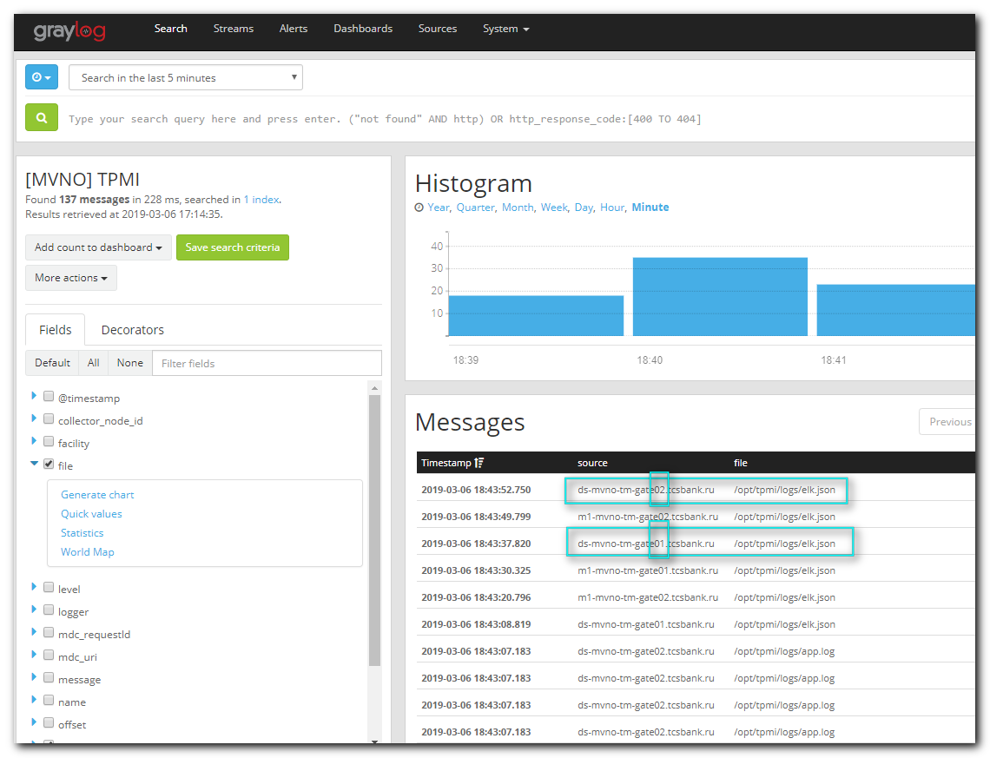

#
# Here is how it should be.
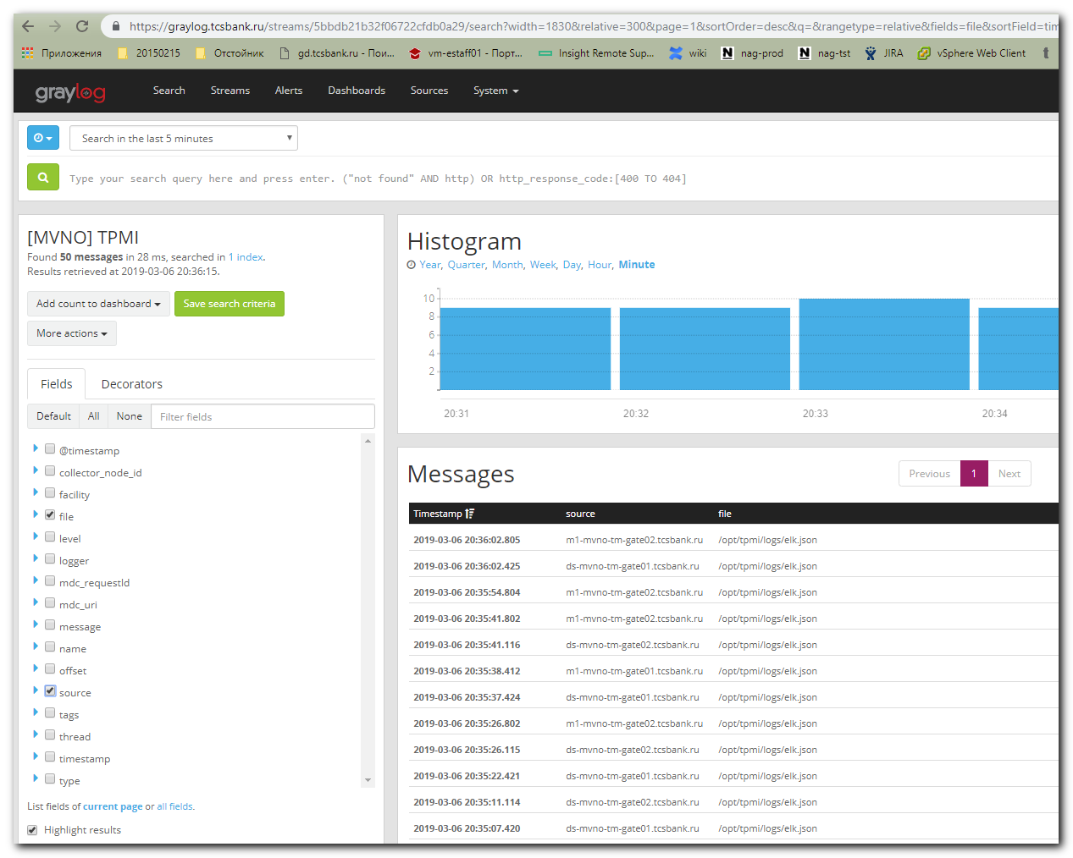

# if need to use filter.
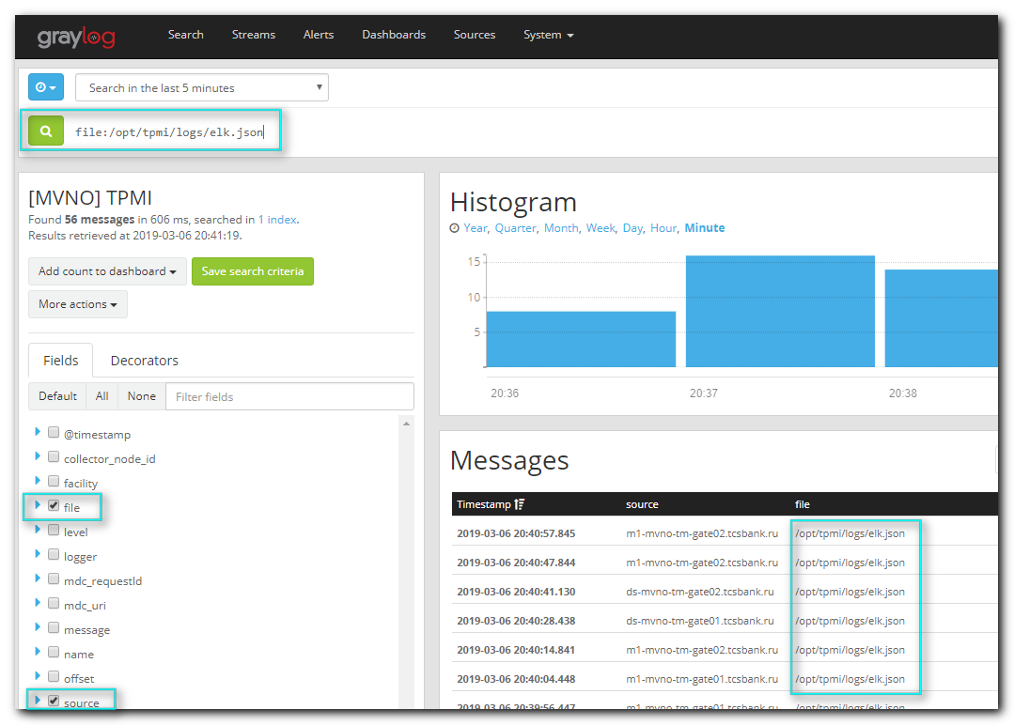

#
# By the way, if I wanted to see logs in network packets, I seen these trash.
#

root@m1-mvno-tm-gate01 ~$ tcpdump -i any port 12624 -w /tmp/$(date +%Y%m%d-%H%M).tcpdump.dat
tcpdump: listening on any, link-type LINUX_SLL (Linux cooked), capture size 262144 bytes
9 packets captured
9 packets received by filter
0 packets dropped by kernel
root@m1-mvno-tm-gate01

root@m1-mvno-tm-gate01 ~$ tshark -r /tmp/20190307-1704.tcpdump.dat
Running as user "root" and group "root". This could be dangerous.
1 0 10.250.0.4 -> 10.216.40.170 TCP 4278 45446 > 12624 [PSH, ACK] Seq=1 Ack=1 Win=229 Len=4210 TSval=695020845 TSecr=3764405009
2 0 10.216.40.170 -> 10.250.0.4 TCP 74 12624 > 45446 [PSH, ACK] Seq=1 Ack=4211 Win=32723 Len=6 TSval=3764441010 TSecr=695020845
3 0 10.250.0.4 -> 10.216.40.170 TCP 68 45446 > 12624 [ACK] Seq=4211 Ack=7 Win=229 Len=0 TSval=695020849 TSecr=3764441010
4 0 10.216.40.170 -> 10.250.0.4 TCP 68 12624 > 45446 [ACK] Seq=1 Ack=4211 Win=32670 Len=0 TSval=3764441010 TSecr=695020845
5 0 10.250.0.4 -> 10.216.40.170 TCP 68 [TCP Dup ACK 3#1] 45446 > 12624 [ACK] Seq=4211 Ack=7 Win=229 Len=0 TSval=695020849 TSecr=3764441010
6 15 10.250.0.4 -> 10.216.40.170 TCP 3398 45446 > 12624 [PSH, ACK] Seq=4211 Ack=7 Win=229 Len=3330 TSval=695035846 TSecr=3764441010
7 15 10.216.40.170 -> 10.250.0.4 TCP 68 12624 > 45446 [ACK] Seq=7 Ack=7541 Win=32723 Len=0 TSval=3764456011 TSecr=695035846
8 15 10.216.40.170 -> 10.250.0.4 TCP 74 12624 > 45446 [PSH, ACK] Seq=7 Ack=7541 Win=32723 Len=6 TSval=3764456011 TSecr=695035846
9 15 10.250.0.4 -> 10.216.40.170 TCP 68 45446 > 12624 [ACK] Seq=7541 Ack=13 Win=229 Len=0 TSval=695035847 TSecr=3764456011
root@m1-mvno-tm-gate01 ~$

root@m1-mvno-tm-gate01 ~$ ngrep -W byline '' -I /tmp/20190307-1704.tcpdump.dat
input: /tmp/20190307-1704.tcpdump.dat
filter: (ip || ip6)
#
T 10.250.0.4:45446 -> 10.216.40.170:12624 [AP] #1
2W....2C...fx^.]_..Hrw...'..5.+Q<..cIkk3.....}C......HjIjl.1..n......!.\........[.{.....Z..P...j..i4........vWWUwW...G......s.F.7.....'qb.}..eQ*.."......f.r........|........o.;.....H.......}....:|.?&Q...o.....
....v:1IxC+)..i%9..$............0y..0R4D.....K.+*.(.|..{.....R.}...%G..],.8.+RAQ4.$
.&.."...c..3......'5F..j..h.@..[PuE...h.DQe....E]6..A.a.[v.....V.$...=.rIb{=.?...n.DH.....<
;.|....=H...A.... 9"A.9v...A..{.|.|.8...[......RZ..\.......'.Z..}.n..-!..T.#1L.9.]M....n.u.mO.......z....?L..$O.L.........l.>...BJj[..JA#E...Q..N...........7L^...&....2..Ir.2.:.o..~$..$..[[h......Q>.......U...
...(f..q..OL.84y...y....1..<..(.j....t.i.g^?.....A4H7H.....H..&...}VW...8...M..!}..y....0HH...$.&G.FU..b]..~!..0|....M..f.....k.. t.(...(....@+HR..-|..St..5M.#...n.J.&............F.J.
yE..t.........x..vk..Vm.n...j..UP...|......M..d.9(_..52....mL..D..C........M......N....!...%...z\:.....h....[.o"Y.....^......=.|...~Z..<.$cR..,....$..0J.F$.DA3.... ..[+-...R..........&.....,....t.8.#.r.(t.;..w
...[...*..|......V.`...SmY.....U..vj..gG.x...Z~.O.Qo.s/....E...B.sI...h.r..)d.........o...x.5c......,..x=b13.:=..-.,m.J^..+..&.4\..x).n.NG,
.Sr.....^*...8.R.DU.U...%V.X..)/.DW.+.%....[B. ......~.(.e..&+.z^..+.]t....JIa*.x).z)Z.9........O.N...I....;*z^..&....I......T.u..j.j..Z.5.....xJ.s.z...[tZ.k..rb@...+....w......m..$^.^..^.ek^.bs.....4..\D.A/..
..,r.o>...=.....s.ms .
...-c.......3....|..J.......L.b.x.,.zv.X..gz
....-.=...9..=.Y...b.y$..?.....*...~.....'...N....3..r..N..!42..#;.......QL..wN5(.....j.tk9.....=!!.$H.9.b.;gTi..O....-.{D........w.e...#.D `B.a"......!c......A.dJ.L{."f.P..............Sr...]. .L..(.
....)qCE....l..9.......'.M...........A!.p....rV.,.i...Y..hGv)C....-.L.l.fI.O..L.5..ALn.5...d[.qi."..."Ws.%I....xl<..N....?.?._..._._.8V.+.......[.o9.o'Q.<.=.*~O.K......K.k.;.?9........8..Q.EM........:....bI..D
.&Q.....aI,@.D.K.a..,.1......>....F..Z....._..0b.
...

root@m1-mvno-tm-gate01 ~$ ngrep -W byline '' host 10.216.40.170 and port 12624
interface: eth0 (10.250.0.0/255.255.255.0)
filter: ( host 10.216.40.170 and port 12624 ) and ((ip || ip6) || (vlan && (ip || ip6)))
#
T 10.250.0.4:52504 -> 10.216.40.170:12624 [AP] #1
2W....2C...Yx^...n.....8.ktp.l...!J....W...cX
..4.!9..!9....k.h.'..W......M...7.GX..7v... kH........w...G...S....3x"iJ..i.....WuK.{c....k.Z....
<I......3....BL...,A.y..p!b!(pB..,...ZG3`..`.....f.l.<...MD......(..!.....O..^u
..l.D[../."UU..+.[F...N_W..6..1r..'.
".0.8$..L....Fj'.z*.q......z...HA...6.i;L(.d{B./.@......Np....BD..kR....T.,.d.z!.$.4...l........^......d..X..E".!(.s&r.J..=.y..p!a..)..,+....T .i...jz.1U...K....E..../@.).r..Y.Zm.`8.cA$.....FWW@........).c.h..
.......M..bJ.HT.M....*.?dIBB.8...[..0............P....#N`.A...U...y?c..itW~f.....Z..{....8.1....-..{..~{..|..UP!...T.
....1..&i....V.d..x..n........f...p.2I<P...].^U...!..$XR...c..11.0.....A9g..,....n..Q{..w=0t..u....^.R".,.}..G..VpZ..R.n.]....q.......^oJpD...=.`..S.............+.l.L.L.;$..i.4;.}.&AG..<O.x....RS...UI..7...9T.
.N..~.x...J..L. `.is...p..Wg..7..a;=..`6.$v..k./...-.`..NQ!l..f.4..F.R...~..j..Z1..W..ok.K../..w....A....GVM6H.....h4..m3.$...4L..".....d.b"y1.m].|...a.j*...........R.+.e%C........i.+.|O.>...:..fO.[..R.O...nT.
.......Z....IB....q.....D.'hc..3.{.omX.xs.W.....C.....X.Y.......c...~.x]..D....{i...KB.FV.n.....duY..w).c../tg}.~s.z? .H$b1
.U..Y..*..^V>.x..[..MA....~."r.#.....i...k.5.5Km...t.]..AV$.......A..|_.X./?..FV...::.....{......._..9.[.\~,?.^f.{..P..L]G.O.....YZ..X;.._........v:s.......a.d.../...........c.I....{.XP..g.+.[.
U...E~.....w_.n+...^..x.......L."g. s.....G.h.f......hc.d
#
...

root@ds-mvno-tm-tpnd01 ~$ ngrep -W byline '' host 10.216.40.170 and port 12624
interface: eth0 (10.250.1.0/255.255.255.0)
filter: ( host 10.216.40.170 and port 12624 ) and ((ip || ip6) || (vlan && (ip || ip6)))
#
T 10.250.1.10:36640 -> 10.216.40.170:12624 [AP] #1
2W....2C....x^.....6..;..1u.%.G...-..!.L`g..&..a..r....X....{.q..a.K.......K.K................}....JR...2.>...GN..........P"....Q..0h.=..)......$........:.y...z....bD..|6>Y..1..U.......|^ .G..}....V.....5.....x.K.s...}..[.(rF..H... ............
.3
...eV....d.....'4...F...=..l@Ud.1.....U......U.....N8.....m.n...`~..Y.w..AK....g.....{..k.=Z..).;8ySW-...m.\..%.MZ&oV.=.....o....P.d.5.>.t]./.*nx.....xA...MI...:HWL...J....[......wq...m...+.v...........O.+~..K7).l...{.&..%.k...8NF.x[/m..v.....11.....r.=.{....../.$f1....Sn.y..\.n.aK.o.sEH..y/...cz.J...k.WH..e..1..)....1..o.d.{....B
n.<..e]..!).q....m('........eps...y.p.Nqj...u........?..a;..t.<.@y.. i.):`F.c..R5..$C.......j
/...)|....@............
#
T 10.216.40.170:12624 -> 10.250.1.10:36640 [AP] #2
2A....
#exit
3 received, 2 matched
root@ds-mvno-tm-tpnd01 ~$

